**VIVEKANAND EDUCATION SOCIETY’S**

**INSTITUTE OF TECHNOLOGY**

**Department of Computer Engineering**



Project Report on

AI-Enhanced Imaging for Early Detection of Brain Anomalies

In partial fulfillment of the Fourth Year (Semester–VII), Bachelor of Engineering

(B.E.) Degree in Computer Engineering at the University of Mumbai Academic Year 2023-2024

**Mrs. Nusrat Ansari**

**Submitted by**

Vedansh Udhawani D17B/68

Abhishek Chhabria D17B/15

Chirag Dodeja D17C/17

Romesh Lulla D17C/31

(2023-24)

**VIVEKANAND EDUCATION SOCIETY’S**

**INSTITUTE OF TECHNOLOGY**

**Department of Computer Engineering**

**CERTIFICATE of Approval**

This is to certify that ***Vedansh Udhawani, Abhishek Chhabria, Chirag Dodeja, Romesh Lulla*** of Fourth Year Computer Engineering studying under the University of Mumbai has satisfactorily presented the project on “***AI-Enhanced Imaging for Early Detection of Brain Anomalies***” as a part of the coursework of PROJECT-I for Semester-VIII under the guidance of ***Mrs. Nusrat Ansari*** in the year 2023-2024.

Date : 01/04/24

__________________ __________________ Internal Examiner External Examiner

_________________ __________________ __________________

Project Mentor Head of the Department Principal

Dr. Mrs. Nupur Giri Dr. J. M. Nair

**ACKNOWLEDGEMENT**

We are thankful to our college Vivekanand Education Society’s Institute of Technology for considering our project and extending help at all stages needed during our work of collecting information regarding the project.

It gives us immense pleasure to express our deep and sincere gratitude to Assistant Professor **Mrs. Nusrat Ansari** for her kind help and valuable advice during the development of project synopsis and for her guidance and suggestions.

We are deeply indebted to Head of the Computer Department **Dr.(Mrs.) Nupur Giri** and our Principal **Dr. (Mrs.) J.M. Nair ,** for giving us this valuable opportunity to do this project.

We express our hearty thanks to them for their assistance without which it would have been difficult in finishing this project synopsis and project review successfully.

We convey our deep sense of gratitude to all teaching and non-teaching staff for their constant encouragement, support and selfless help throughout the project work. It is a great pleasure to acknowledge the help and suggestion, which we received from the Department of Computer Engineering.

We wish to express our profound thanks to all those who helped us in gathering information about the project. Our families too have provided moral support and encouragement several times.

**Computer Engineering Department**

**COURSE OUTCOMES FOR B.E PROJECT**

Learners will be to:-

| **Course Outcome** | **Description of the Course Outcome** |
| --- | --- |
| CO 1 | Able to apply the relevant engineering concepts, knowledge and skills towards the project. |
| CO2 | Able to identify, formulate and interpret the various relevant research papers and to determine the problem. |
| CO 3 | Able to apply the engineering concepts towards designing solutions for the problem. |
| CO 4 | Able to interpret the data and datasets to be utilised. |
| CO 5 | Able to create, select and apply appropriate technologies, techniques, resources and tools for the project. |
| CO 6 | Able to apply ethical, professional policies and principles towards societal, environmental, safety and cultural benefit. |
| CO 7 | Able to function effectively as an individual, and as a member of a team, allocating roles with clear lines of responsibility and accountability. |
| CO 8 | Able to write effective reports, design documents and make effective presentations. |
| CO 9 | Able to apply engineering and management principles to the project as a team member. |
| CO 10 | Able to apply the project domain knowledge to sharpen one’s competency. |
| CO 11 | Able to develop a professional, presentational, balanced and structured approach towards project development. |
| CO 12 | Able to adopt skills, languages, environment and platforms for creating innovative solutions for the project. |

INDEX

| Chapter No. | Title | Page No. |
| --- | --- | --- |
| **1** | **Introduction** | 8 |
| 1.1 | 1.1. Introduction to the project | 8 |
| 1.2 | 1.2. Motivation for the project | 9 |
| 1.3 | 1.3. Drawback of the existing system | 10 |
| 1.4 | 1.4. Problem Definition | 10 |
| 1.5 | 1.5 Relevance of the Project | 11 |
| 1.6 | 1.6 Methodology used | 13 |
| 2. | Literature Survey  2.1. Research Papers  a. Abstract of the research paper  b. Inference drawn from the paper | 14 |
| 3. | Requirement Of Proposed System  3.1 Functional Requirements  3.2. Non-Functional Requirements  3.3. Constraints  3.4. Hardware & Software Requirements  3.5. Techniques utilized till date for the proposed system  3.6. Tools utilized till date for the proposed system | 18 |
| 4. | Proposed Design  4.1 Block diagram representation of the proposed system  Explanation for the block diagram  4.2. Modular diagram representation of the proposed system  Explanation for the modular block diagram  4.3 Design of the proposed system with proper explanation of each :  a. Data Flow Diagrams  b. Screenshot of implementation  4.4 Algorithms utilized in the existing systems | 25 |
| 5. | Proposed Results and Discussions  5.1.Determination of efficiency  5.2. Confusion Matrix | 33 |
| 6. | Plan of Action For the Next Semester  6.1.Work done till date  6.2.Plan of action for project II | 34 |
| 7. | Conclusion | 36 |
| 8. | References (In IEEE format) | 37 |
| 9. | Appendix  9.1.List Of Figures  9.2.List Of Tables | 38 |

**ABSTRACT**

Fetal brain anomalies are characterized by the abnormal development of brain structures during fetal development, which can have significant and long-lasting implications for a child's health and well-being. The prevalence of these anomalies has been increasing, leading to a heightened concern among medical professionals and researchers.

Preventing fetal brain anomalies is challenging, but the risk factors can be mitigated with early detection and intervention. Early detection is essential for improving the prognosis and outcomes for affected infants, making it crucial for healthcare providers and expectant parents.

The number of pregnancies at risk for fetal brain anomalies is on the rise, underscoring the need for advanced diagnostic tools. Machine learning and deep learning techniques offer a promising avenue to expedite the detection of these anomalies, enabling researchers to analyze a large volume of fetal brain images more efficiently and cost-effectively.

Computer-aided diagnosis (CAD) has emerged as a powerful approach for detecting fetal brain anomalies, offering doctors an additional tool for accurate and timely identification of developmental issues in the fetal brain. In light of this, our investigation and evaluation aim to propose an innovative model that enhances and addresses the limitations of existing approaches.

**Chapter 1 : Introduction**

**1.1 Introduction to the project**

The intricate journey of human life begins with the formation and development of the fetal brain, a process that commences during the embryonic phase around the third week of gestation and progresses throughout the fetal period, ultimately reaching its zenith at approximately the 24th week of pregnancy. Within this remarkable timeframe, the fetal brain undergoes a series of intricate transformations, laying the foundation for the complex neurological system that will guide an individual's entire existence.

This juncture, spanning from approximately 22 to 24 weeks of gestation, holds profound significance in the realm of prenatal care and fetal health. It marks a pivotal window of opportunity for detecting potential anomalies within the developing fetal brain, a critical period roughly equivalent to the midpoint of a full-term pregnancy, which spans around 5 to 6 months.

The importance of this time frame cannot be overstated, as certain fetal brain anomalies may pose substantial risks to both maternal and fetal health. It is noteworthy that the likelihood of a newborn manifesting a brain abnormality upon live birth is minimal, estimated at a mere 0.2%. However, the probability of such anomalies in the context of stillbirth is notably higher, standing at 6%. This stark contrast underscores the urgency of expedited identification and diagnosis during the prenatal period.

In light of these considerations, our project assumes a paramount role in advancing the field of prenatal care. We embark on a journey at the intersection of cutting-edge technology and healthcare, specifically focusing on AI-enhanced imaging for the early detection of fetal brain anomalies. Our mission is to harness the power of Artificial Intelligence to enhance the sensitivity and accuracy of fetal brain anomaly detection during this critical window of gestation.

By developing and evaluating AI-enhanced imaging systems, we aspire to provide expectant mothers and healthcare professionals with a reliable tool that can facilitate early diagnosis, informed decision-making, and timely interventions. Through this research, we aim to reduce the potential risks associated with fetal brain anomalies and thereby contribute to the well-being of both mothers and their unborn children.

This project report will delve into the theoretical foundations, practical implementations, data sources, and results of our research, illuminating the transformative potential of AI in the field of prenatal care. As we navigate through the complexities of fetal brain development, AI-enhanced imaging, and the imperatives of maternal-fetal health, we aspire to offer a glimpse into a future where technology and compassion converge to safeguard the most vulnerable stage of human life.

**1.2 Motivation for the project**

The motivation behind our project, "AI-Enhanced Imaging for Early Detection of Brain Anomalies," stems from the profound importance of the critical window in fetal brain development, which spans from approximately 22 to 24 weeks of gestation. During this pivotal period, the foundation of an individual's neurological system is laid, and any anomalies that may arise hold the potential to impact both maternal and fetal health significantly.

The urgency of this project is underscored by the statistics revealing a significantly higher probability of fetal brain anomalies leading to stillbirth, which stands at 6%, compared to the minimal 0.2% likelihood of such abnormalities manifesting in live births. These statistics emphasize the need for early detection and intervention during pregnancy to mitigate the risks associated with these anomalies.

Moreover, the rapid advancements in Artificial Intelligence have opened up new horizons in the field of medical imaging, offering unprecedented opportunities to enhance our ability to diagnose and address fetal brain anomalies with greater precision and efficiency. Leveraging AI in prenatal care has the potential to revolutionize the way we approach fetal health, providing expectant mothers and healthcare professionals with a powerful tool for early detection and intervention.

Our motivation, therefore, lies in the potential to make a significant impact on the well-being of mothers and their unborn children. By developing AI-enhanced imaging systems tailored for fetal brain anomaly detection, we aim to empower healthcare providers with the means to identify issues early, leading to informed decisions and improved health outcomes for both mothers and their future generations. This project's driving force is the aspiration to harness technology's capabilities for the greater good of maternal and fetal health, ushering in a future where early detection becomes synonymous with early intervention and improved outcomes.

**1.3 Problem Definition**

The primary goal of our project is to address the critical challenge of early detection of fetal brain anomalies during pregnancy. Fetal brain anomalies, encompassing a wide spectrum of conditions, pose substantial risks to both maternal and fetal health. Our objective is to develop a highly accurate classifier that can differentiate between normal and abnormal fetal brain conditions, while also being capable of pinpointing specific types of anomalies using advanced image processing techniques to enhance classification accuracy.

The problem at hand involves several key facets:

* **Early Anomaly Detection:** Timely identification of fetal brain anomalies is paramount. Our system must have the capability to detect abnormalities as early as possible during the gestational period, ideally before complications arise, allowing for timely interventions and informed decision-making.
* **Classification Accuracy:** The accuracy of anomaly classification is pivotal. We aim to create a classifier that not only identifies the presence of an anomaly but also distinguishes between various types of anomalies. This fine-grained classification is crucial for tailoring treatment plans and providing expectant parents with comprehensive information.
* **Ethical Considerations:** Ensuring patient privacy, informed consent, and adherence to ethical guidelines are paramount in the development and deployment of our system. We must address these ethical considerations to maintain the trust of patients and healthcare providers.

In essence, our project seeks to bridge the gap between cutting-edge technology and the critical needs of prenatal care. By developing an accurate and advanced classifier for fetal brain anomaly detection, we aim to improve the early diagnosis and management of these conditions, ultimately contributing to better maternal and fetal outcomes, informed decision-making, and enhanced prenatal care.

**1.4 Lacunas of the existing system**

Despite significant advancements in medical imaging and diagnostic technologies, existing systems for detecting fetal brain anomalies face several notable drawbacks and challenges:

1. **Lack of Freely Available Annotated Datasets:** One major limitation is the scarcity of freely available, well-annotated datasets specific to fetal brain imaging. Developing accurate AI algorithms heavily relies on access to comprehensive and diverse datasets, which are often limited in this specialized domain. This scarcity hinders the development and evaluation of robust AI systems.
2. **Complexity of Fetal Brain Anatomy:** The fetal brain is an incredibly complex and rapidly developing organ. Detecting anomalies requires a deep understanding of fetal brain anatomy, which is inherently challenging due to its intricate structure and the dynamic nature of development. Current systems struggle to account for this complexity adequately
3. **Variability in Fetal Positioning:** Fetal positioning within the womb can introduce variability in imaging quality and accuracy. Different orientations and positions can obscure anomalies or make them more challenging to detect. Existing systems may not effectively address this variability.

Addressing these drawbacks is essential for improving the reliability and effectiveness of systems for detecting fetal brain anomalies. Overcoming these challenges will require the collaborative efforts of researchers, healthcare professionals, and technology developers to develop more robust and adaptable solutions that can enhance prenatal care and ensure the early detection of these critical anomalies.

**1.5 Relevance of the Project**

The relevance of our project, "AI-Enhanced Imaging for Early Detection of Brain Anomalies," extends far beyond the confines of scientific research and technology development. It holds profound significance in the realm of healthcare, particularly within the domain of prenatal care and fetal health. Here are several key facets that underscore the project's immense relevance:

1. **Improved Maternal and Fetal Outcomes:** Early detection of fetal brain anomalies is directly linked to improved maternal and fetal outcomes. By providing a tool that can detect these anomalies at an early stage, our project has the potential to mitigate risks, facilitate timely interventions, and ultimately enhance the well-being of both expectant mothers and their unborn children.
2. **Informed Decision-Making:** An accurate and early anomaly detection system empowers expectant parents with valuable information. It enables them to make informed decisions about their pregnancy and allows healthcare providers to tailor treatment plans accordingly. This aspect of informed decision-making is pivotal in ensuring the best possible care for both mother and baby.
3. **Advancement of Prenatal Care:** The project aligns with the broader goal of advancing prenatal care. As technology and healthcare converge, our research seeks to pave the way for more sophisticated and effective prenatal diagnostic tools. This advancement is critical in addressing the evolving healthcare needs of expectant mothers and promoting healthier pregnancies.
4. **Global Healthcare Impact:** Fetal brain anomalies are a global concern, affecting individuals from diverse backgrounds and geographical locations. Our project's relevance extends across borders, as it seeks to provide a universally applicable solution that can be integrated into healthcare systems worldwide, thereby benefiting a broad spectrum of populations.
6. **Ethical Imperatives:** Ensuring that expectant mothers receive the best possible care is an ethical imperative. By prioritizing ethical considerations throughout the project, we reaffirm our commitment to upholding the highest standards of patient care and respecting the principles of autonomy, privacy, and informed consent.

In conclusion, the relevance of our project is deeply intertwined with the broader goals of healthcare improvement, informed decision-making, and the well-being of expectant mothers and their unborn children. By harnessing the potential of AI-enhanced imaging for early detection of fetal brain anomalies, we aspire to make a lasting and positive impact on prenatal care, healthcare economics, and the lives of countless families worldwide.

**Chapter 2: Literature Survey**

**2.1. Research Papers Referred**

| **Author** | **Title** | **Abstract** |
| --- | --- | --- |
| H N Xie N Wang , M He , L H Zhang , H M Cai  [Link](https://www.ncbi.nlm.nih.gov/pmc/articles/PMC10294149/) | Review of deep learning and artificial intelligence models in fetal brain magnetic resonance imaging | * This approach involves key steps for assessing fetal brain structures:   1. Detection of the region of interest (ROI) using a two-stage anisotropic U-Net.  2. Selection of a reference point using a CNN.  3. Computation of linear measurements.  4. Estimation of reliability using a Gaussian Matrix.   * Fetal MRI, in addition to ultrasound, is increasingly used to detect brain disorders in fetuses, offering a more precise examination. * It aids in detecting abnormalities like ventriculomegaly, missing corpus callosum, and posterior fossa anomalies. * However, limited publicly available fetal brain MRI datasets pose challenges for AI algorithm development in this area. |
| H N Xie N Wang , M He , L H Zhang , H M Cai  [Link](https://pubmed.ncbi.nlm.nih.gov/31909548/) | Using deep-learning algorithms to classify fetal brain  ultrasound images as normal or abnormal | * The study provides a heat map for Lesion localization * This study is the first to use and verify the feasibility of CNN based deep learning classifier for binary classification * The heat map indicated the area where the algorithm had highest activation, not necessarily where the classification result was derived. There were instances when the heat map highlighted regions, yet the classification result remained accurate. * The study takes into account various standard planes for training and classification, yet it does not address various anomalies that can occur in the fetal brain. |
| Ruowei qu, guizhi xu, chunxia ding, Wenyan jia, and Mingui sun.  [Link](https://ieeexplore.ieee.org/document/9084099) | Standard Plane Identification in Fetal Brain Ultrasound Scans Using a Differential Convolutional Neural Network. | * This study focuses on comparing various models for classifying standard fetal brain MRI imaging planes rather than anomalies. * The models include k-means, RCM, Sononet 32, Sononet 64, CNN+SVM, CNN, pretrained CNN, and differential CNN. * The findings show that the differential CNN achieves higher precision, recall, F1-score, and accuracy in classifying standard imaging planes, which include six standard planes and one non-standard plane. * The differential-CNN employs differential operators to generate feature maps, extracting more image details without adding complexity to the network, leading to superior performance in fetal brain imaging plane identification compared to other deep learning methods. |
| Baihong Xie, Ting Lei, Nan Wang,· Hongmin Cai  [Link](https://pubmed.ncbi.nlm.nih.gov/32488568/) | Computer-aided diagnosis for fetal brain ultrasound images  using deep convolutional neural networks | * The average mean of Intersection over union is 0.497 for Lecision localization. * When the evaluated their model with real world clinical data they received a dice score of 0.942 and f1-score of 0.96 * Another limitation was the data used in this paper, which were from the same center. For training and even for testing the model on real world data * This paper not only classifies the normal and Abnormality of the input images but also localize the region of lesions |
| M. Priya, M. Nandhini  [Link](https://www.sciencedirect.com/science/article/pii/S2665917423001447) | Detection of fetal brain abnormalities using data augmentation and convolutional neural network in internet of things | * This study uses data augmentation techniques such as rotation, shifting, flipping, and zooming to balance the dataset of fetal brain MRI images for training a deep neural model. * In this study these techniques help prevent overfitting and handle dataset imbalances. Normal case images previously 260 are multiplied to balance the dataset, resulting in 540 normal and 615 abnormal case images. * A 22-layer CNN model is proposed to classify fetal brain abnormalities in an IoT healthcare system, considering data from gestational age 16-39 weeks, including 23 types of fetal brain complications. |
| Kavita Shinde, Anuradha Thakare  [Link](https://ieeexplore.ieee.org/abstract/document/9670994) | Deep Hybrid Learning Method for Classification of Fetal Brain Abnormalities | * Recent research aims to improve fetal brain disorder classification using MRI images. * Deep Hybrid Learning (DHL) merges deep learning with traditional methods, achieving superior results with an AUC of 94% for training and 87% for validation, surpassing existing techniques. * The paper discusses future directions and challenges. |
| Wen Shi, Guohui Yan, Yamin Li,  [Link](https://www.sciencedirect.com/science/article/pii/S1053811920308028) | Fetal brain age estimation and anomaly detection using attention-based deep ensembles with uncertainty | * This study introduced an attention-based deep neural network for predicting fetal brain age from routine MRIs with remarkable accuracy. * It also identified fetal anomalies effectively, offering potential clinical prenatal diagnostic utility. |
| P.Durgadevi, S.Vijayalakshmi, Munish Sabbharwal  [Link](https://ieeexplore.ieee.org/abstract/document/9725570) | Scrutiny In-Utero to recognize Fetal Brain MRI Anomalies | * Prenatal MRI outperforms ultrasound in identifying fetal brain abnormalities, critical for conditions such as ventriculomegaly, corpus callosum issues, and posterior fossa anomalies. * Early detection is vital for timely intervention, improving clinical outcomes. * This paper highlights the importance of fetal MRI in diagnosing a variety of brain abnormalities during pregnancy. |

Table 1 : Literature Review

**Chapter 3: Requirement Gathering for the proposed system**

**3.1 Introduction**

Requirement gathering is a crucial stage in the development of any system, including those aimed at fetal brain anomaly detection. The aim of this process is to gather and document the functional and non-functional requirements of the proposed system.

For fetal brain anomaly detection, the requirements may include the ability to accurately and reliably detect and classify various fetal brain anomalies using CT scan images. The system may also need to be user-friendly and easy to use for radiologists and clinicians. The computational resources required for running the machine learning algorithms used in the system may also be a key requirement. Other requirements may include the need for the system to integrate with existing hospital systems and databases and to provide accurate and reliable results within a reasonable time frame.

By gathering and documenting these requirements, the development team can have a clear understanding of what the system needs to do and what features it needs to have to meet the needs of its users. This can help ensure that the system is designed and implemented effectively, and that it meets the needs of its intended users.

**3.2 Functional Requirements**

1. Image processing: The system should be able to process and analyze the fetal brain CT scan image of a patient using image processing techniques to extract key features and patterns related to brain anomalies.
2. Feature extraction: The system should extract key features and patterns. These features may include size, shape, texture, density, and location of the brain anomaly.
3. Classification: The system should be able to classify the extracted features into various types of brain anomalies using machine learning algorithms.
4. Performance evaluation: The system should provide accurate and reliable results by evaluating its performance using standard evaluation metrics such as accuracy, precision, recall and F1-score.
5. Computational resources: The system should be designed to handle the computational demands of the machine learning algorithms used for brain anomalies detection, which may require a high-performance graphics processing unit (GPU) with a high number of CUDA cores and memory bandwidth.

**3.3 Non-Functional Requirements**

1. Reliability: The system should be reliable and able to provide accurate and consistent results.
2. Accuracy: The system should be accurate in detecting lung cancer and minimize false-positive and false-negative diagnoses.
3. Ease of use: The system should be user-friendly and easy to operate for specialists.
4. Maintainability: The system should be easy to maintain and update, with clear documentation and error reporting mechanisms.
5. Ethical Considerations: The system should adhere to ethical guidelines regarding the use of patient data and the implications of its findings. It should prioritize patient welfare and privacy throughout its design and deployment

**3.4 Hardware, Software , Technology and tools utilized**

**Hardware:**

1. High-performance graphics processing unit (GPU) with a high number of CUDA cores and memory bandwidth for efficient machine learning algorithm processing.
2. Sufficient storage capacity to store and retrieve patient data and system files.

**Software:**

1. Operating system: Windows, Linux or macOS.
2. Image processing and analysis software such as OpenCV, or MATLAB.
3. Machine learning frameworks such as TensorFlow, PyTorch or Keras.
4. Programming languages such as Python or C++ for developing the system.

**Technology and Tools:**

1. Convolutional Neural Networks (CNN) for image feature extraction and classification.
2. You Only Look Once (YOLO) algorithm for object detection in medical images.
3. UNET algorithm for semantic image segmentation.
4. Git version control for source code management and collaboration.
5. Integrated Development Environment (IDE) such as PyCharm, Visual Studio Code, etc

**3.5 Constraints**

1. **Availability of CT scan images:** The system requires a large volume of high-quality fetal brain CT scan images for training and testing the machine learning algorithms. The availability of such images may be limited by factors such as data privacy regulations, consent from patients, and access to imaging equipment.
2. **Performance limitations:** The performance of the system may be limited by the available hardware and computational resources. In particular, the system may require a high-performance GPU to process the images and extract the necessary features.
3. **Expertise constraints:** The development team must have the necessary expertise in areas such as machine learning, image processing, and medical imaging to successfully develop and deploy the system. Access to this expertise may be limited by factors such as staffing, budget, and competition for talent.

**Chapter** **4: Proposed Design**

**4.1. Block diagram representation of the proposed system**

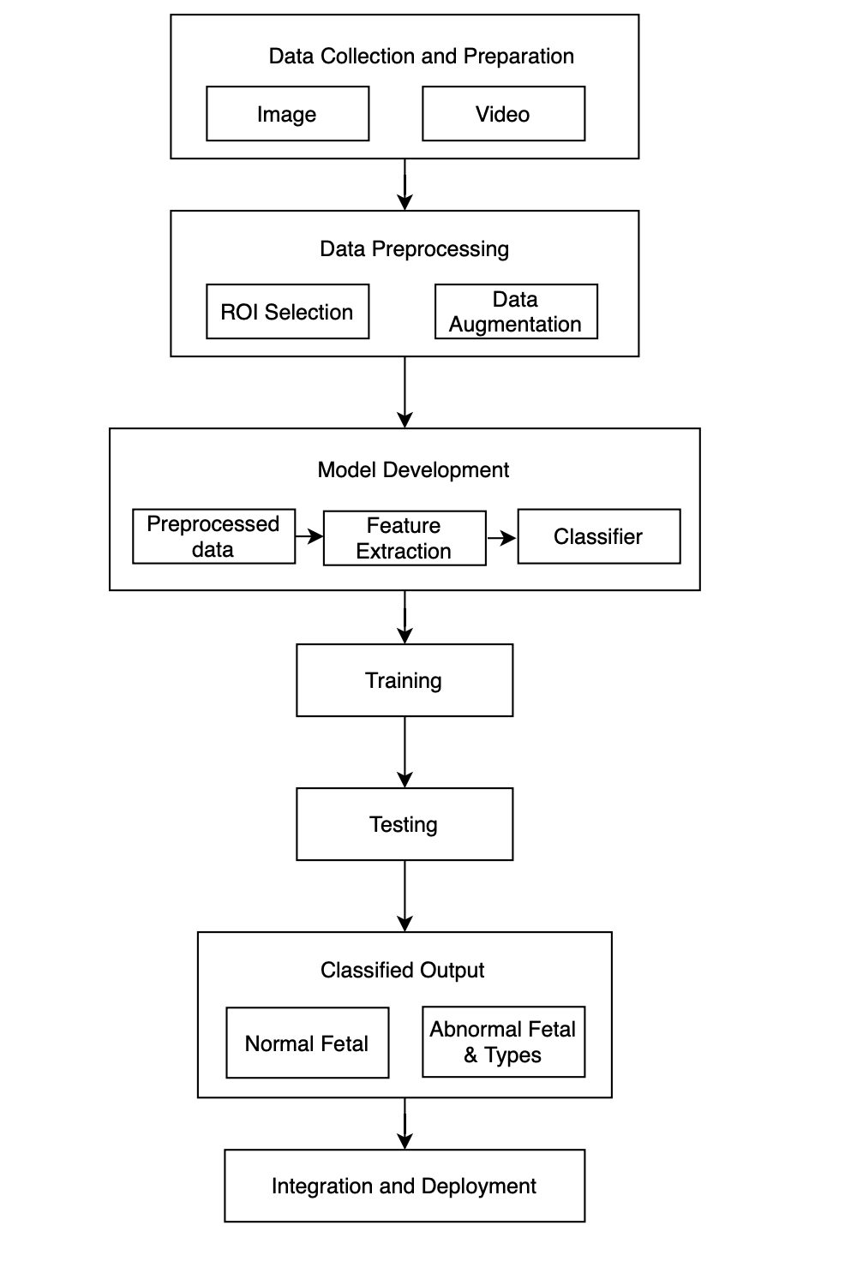

Figure 1 : Block Diagram

**Explanation for the block diagram**

**1. Data Collection and Preparation (Photo):** In this initial step, the system gathers a dataset of medical images of fetal brain scans. These images serve as the foundation for the AI analysis.

**2. Data Preprocessing (ROI Selection):** Before feeding the data into the AI model, the system preprocesses the images. This involves selecting regions of interest (ROI) within the images where the fetal brain is located.

**3. Model Development (Preprocessed Data, Feature Extraction, Classifier):** In this phase, a machine learning or deep learning model is developed. It takes the preprocessed images as input. Feature extraction techniques are employed to identify relevant patterns and information from the images. A classifier is then trained to distinguish between normal and abnormal fetal brain images.

**4. Training:** The model is trained on the preprocessed data, which means it learns from the dataset to recognize patterns that distinguish normal and abnormal fetal brain scans. This training phase helps the model make accurate predictions in subsequent steps.

**5. Testing:** Once the model is trained, it's essential to evaluate its performance. This step involves testing the model using a separate dataset (different from the training data) to assess how well it generalizes to new, unseen images.

**6. Classified Output (Normal and Abnormal Fetal - Types of Anomaly):** After testing, the model can classify new fetal brain images into different categories, typically "normal" and various types of "abnormal." The model identifies specific anomalies and categorizes them accordingly.

**7. Integration and Deployment:** In the final step, the AI model is integrated into a clinical setting. It becomes a part of the healthcare infrastructure for early detection of fetal brain anomalies.

**4.2. Modular diagram representation of the proposed system**

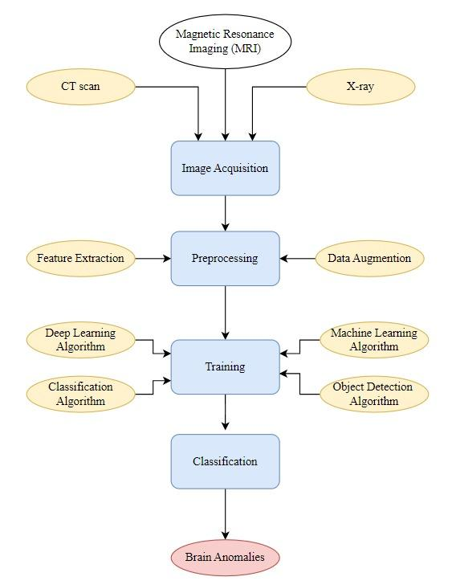

Figure 2 : Modular Diagram

**Explanation for the modular block diagram**

**1. Image Acquisition through Ultrasound, CT Scan, X-ray:** In the first module, medical images are acquired through different imaging modalities such as Ultrasound (Magnetic Resonance Imaging), CT scan (Computed Tomography), and X-ray. These imaging techniques provide diverse data sources for early detection of brain anomalies.

**2. Preprocessing by Using Feature Extraction:** After image acquisition, the preprocessing module is responsible for enhancing and refining the data. Feature extraction techniques are applied to isolate relevant characteristics from the images, making it easier for the AI system to identify anomalies.

**3. Training by Using Deep Learning Algorithm, Classification Algorithm, ML Algorithm, Object Detection Algorithm:** This module is the heart of AI model development. The system employs a variety of algorithms, including deep learning for intricate pattern recognition, classification algorithms to categorize anomalies, machine learning algorithms for overall data analysis, and object detection algorithms to pinpoint specific regions of interest within the images.

**4. Classification:** In this module, the AI system applies the knowledge and patterns learned during training to classify the brain images. It distinguishes between normal brain scans and those with anomalies based on the features extracted during preprocessing and the algorithms applied during training.

**5. Brain Anomalies:** The final output module of the system provides the results. It identifies and categorizes detected brain anomalies, such as tumors, lesions, or structural irregularities. These findings are critical for healthcare professionals in making informed clinical decisions and providing early intervention when necessary.

This modular approach to AI-enhanced imaging streamlines the process of early detection of brain anomalies. It ensures that data from various imaging modalities is properly preprocessed, that the AI model is trained effectively using diverse algorithms, and that the outcomes are clearly presented for medical diagnosis and intervention.

**4.3. Detail Design**

**a. Data Flow Diagram ( Level 0,1)**

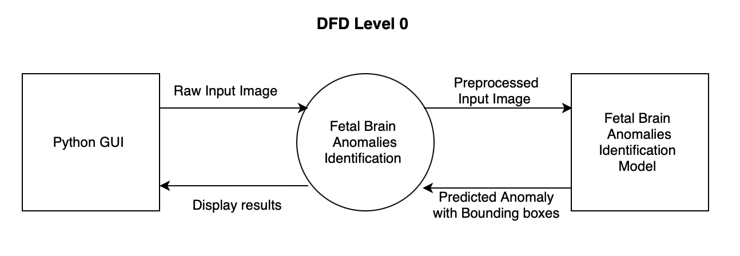

Figure 3 : DFD Level 0

* User Interface (Python GUI): The graphical user interface built using a Python GUI framework, allowing user interaction with the system.
* Fetal Brain Anomalies Identification Model: A machine learning model, possibly a deep learning model, is employed for identifying anomalies in fetal brain images.
* Anomalies Identification: The preprocessed image is passed to the anomaly detection model to identify anomalies within the fetal brain region.

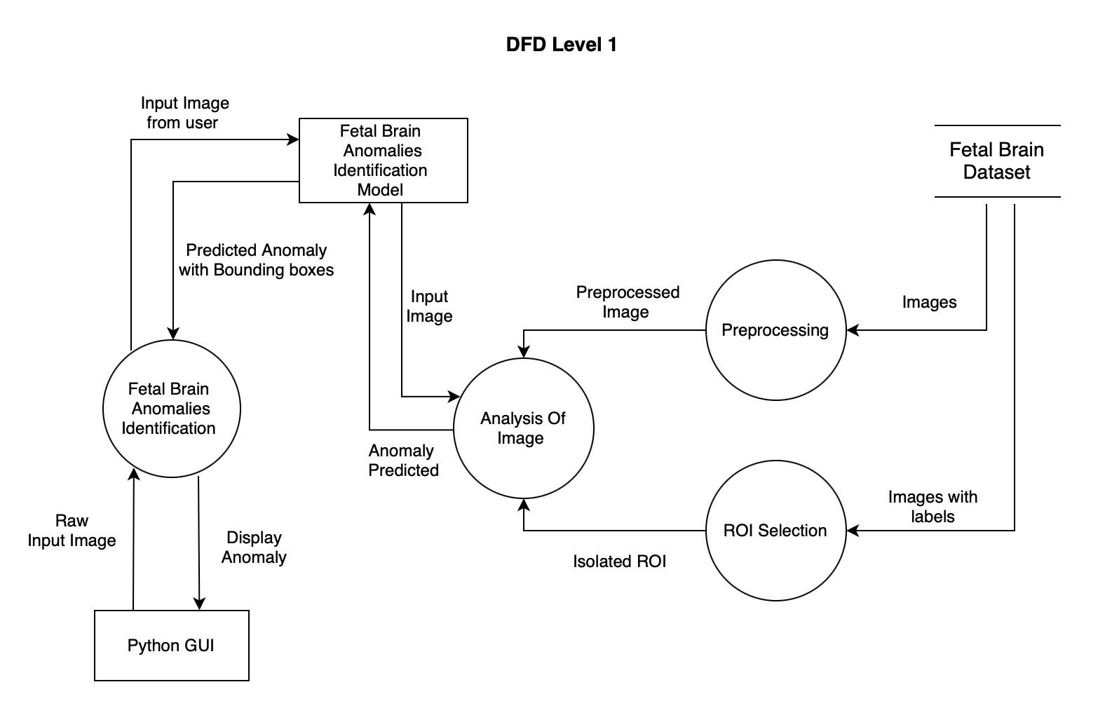

Figure 4 : DFD Level 1

* User Interface (Python GUI): The GUI allows users to interact with the system and upload a raw input image.
* Raw Input Image: The user uploads a raw ultrasound image of the fetal brain through the GUI.
* Preprocessing: Preprocessing tasks, such as noise reduction, resizing, and gray scaling, normalization, are performed on the raw input image.
* ROI (Region of Interest) Selection: The ROI selection isolates the fetal brain region from the rest of the image.
* Fetal Brain Anomalies Identification Model: This model is responsible for identifying anomalies within the isolated ROI.
* Analysis of Image Isolated ROI: After detecting anomalies, further analysis or feature extraction may be performed on the isolated ROI to provide additional information to the user.
* Fetal Brain Dataset (Images):This dataset consists of a collection of fetal brain images used for training the anomaly detection model.

**5. Implementation of the Proposed System**

**5.1 Methodology employed for development**

The steps followed in the project are:

1. **Data Collection and Preparation :** In this initial step, the system gathers a dataset of medical images of fetal brain scans. These images serve as the foundation for the AI analysis.

Link for dataset: [Dataset Link](https://universe.roboflow.com/g-kmlyw/fetal_brain_anomalies)

1. **Data Preprocessing (ROI Selection):** Before feeding the data into the AI model, the system preprocesses the images. This involves selecting regions of interest (ROI) within the images where the fetal brain is located.

Step 1 : Importing libraries and dataset. Step 2 : Resizing the image into 640x640

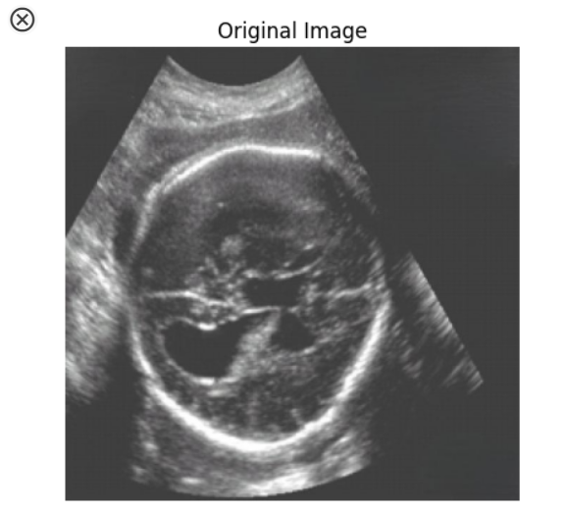 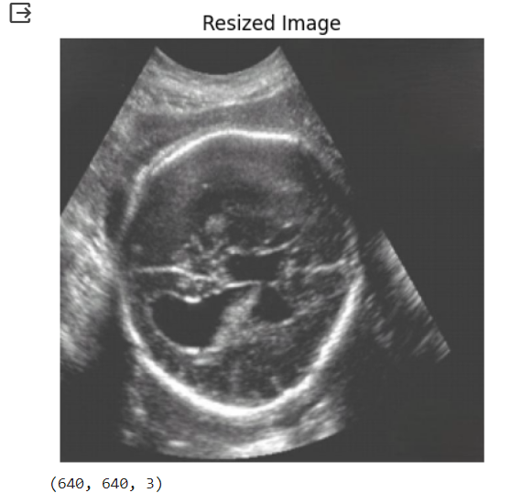

Step 3 : Converting Image to grayscale Step 4 : Normalize the Image [0,1].

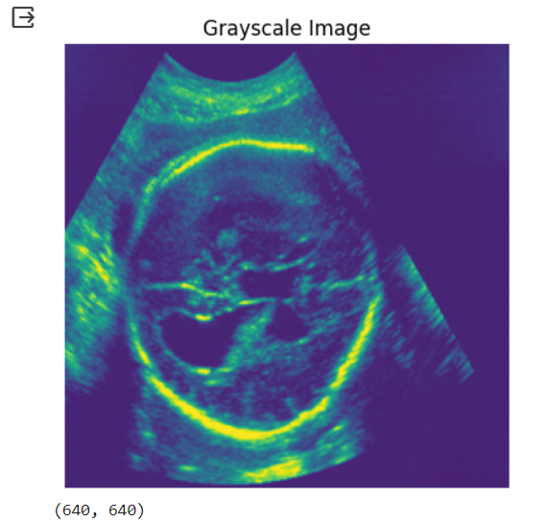 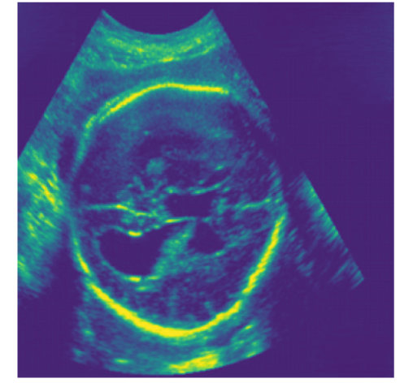

Step 5 : Converting into Binary and Threshold masks. Step 6 : Mask with Bounding Box.

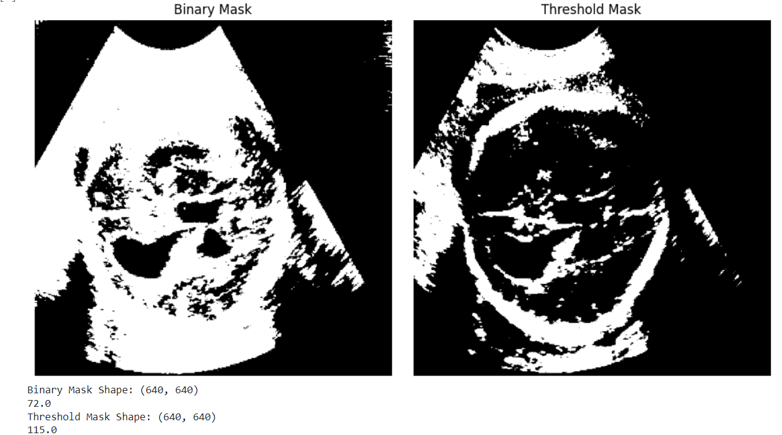 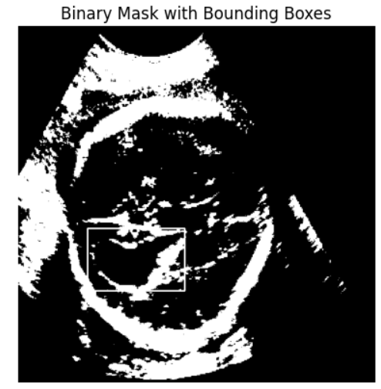

Step 7 : Applying XOR operation to get Isolated ROI Image

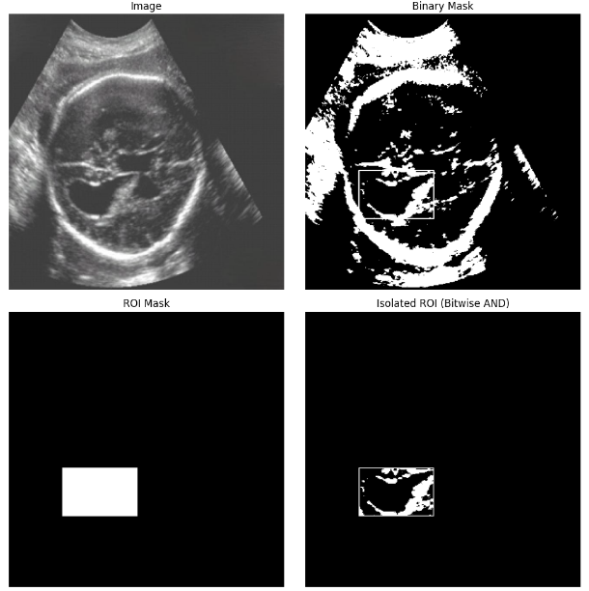

Step 8 : ROI

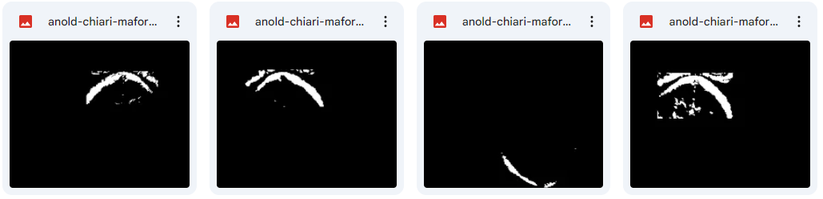

1. **Model Development (Preprocessed Data, Feature Extraction, Classifier):** In this phase, a machine learning or deep learning model is developed. It takes the preprocessed images as input. Feature extraction techniques are employed to identify relevant patterns and information from the images. A classifier is then trained to distinguish between normal and abnormal fetal brain images.The classifiers used in this process are ResNet50, YOLOv5, YOLOv7, and UNet.

ResNet50:

Explanation: ResNet50 is a convolutional neural network (CNN) architecture renowned for its depth and residual connections, enabling the training of deep networks effectively. It's employed here for feature extraction, capturing intricate patterns within preprocessed fetal brain images.

Category: Convolutional Neural Network (CNN)

YOLOv5 and YOLOv7:

Explanation: YOLO (You Only Look Once) versions 5 and 7 are state-of-the-art object detection models that excel at real-time detection tasks. By detecting and localizing abnormalities within fetal brain images, they play a pivotal role in diagnosing anomalies.

Category: Object Detection Models

UNet:

* 1. Explanation: UNet is a convolutional neural network architecture specifically designed for semantic segmentation tasks. It excels in capturing fine-grained details and accurately delineating boundaries, making it ideal for segmenting abnormal regions within fetal brain images.
  2. Category: Semantic Segmentation Model

1. **Training:** During the training phase, the model learns from the preprocessed dataset, enabling it to discern patterns that differentiate between normal and abnormal fetal brain scans. This process enhances the model's ability to provide accurate predictions in subsequent tasks.

The dataset comprises a total of 1391 images, classified into 14 categories, with each image sized at 640x640 pixels. The dataset is partitioned into three subsets for training, validation, and testing:

Training: 974 images (70% of the dataset) are allocated for training the model.

Validation: 357 images (26% of the dataset) are set aside for validating the model's performance during training, aiding in parameter tuning and preventing overfitting.

1. **Testing:** Once the model is trained, it's essential to evaluate its performance. This step involves testing the model using a separate dataset (different from the training data) to assess how well it generalizes to new, unseen images.60 images (4% of the dataset) are reserved exclusively for evaluating the model's performance post-training. These images are distinct from those used for training and validation, ensuring an unbiased assessment of the model's generalization capability.
2. **Classified Output (Normal and Abnormal Fetal - Types of Anomaly):** After testing,the model can classify new fetal brain images into different categories, typically "normal" and various types of "abnormal." The model identifies specific anomalies and categorizes them accordingly.
3. **Integration and Deployment:** In the final step, the AI model is integrated into a clinical setting. It becomes a part of the healthcare infrastructure for early detection of fetal brain anomalies. This integrated system assists medical professionals in making informed decisions about patient care based on AI-enhanced imaging analysis.

Fetal Brain Anomalies with Description and Identification :

| Index | Fetal Brain Anomalies | What is | Identification |
| --- | --- | --- | --- |
| 1 | An old chiari malformation | Chiari malformation are structural defects in the cerebellum. Brain tissue extends into the spinal canal. It can happen when part of the skull is too small, which pushes the brain tissue down | Chiari malformation means that the part of the brain called the cerebellar tonsils that extend below the level of the foramen magnum (the opening at the base of the skull through which the spinal cord passes). |
| 2 | Arachnoid cyst | A fluid accumulation occurs in the arachnoid membrane. It is benign meaning it is of no consequence. It pushes against the vital structure of the brain causing problems | Arachnoid cysts typically appear as well-defined, fluid-filled spaces within the brain.They appear bright in MRI due to the high fluid content. |
| 3 | Cerebellar hypoplasia | Cerebellar hypoplasia is a congenital condition where the cerebellum is underdeveloped. | cerebellar hypoplasia may result in a "bat-wing" or "butterfly" appearance of the cerebellum. Examine both cerebellar hemispheres for any size discrepancy or irregularities. |
| 4 | Cisterna Magna | A cerebrospinal fluid (CSF) filled space in the posterior cranial fossa of the brainstem and cerebellum | The cisterna magna is like a dark space in the brain that looks like cerebrospinal fluid. It's surrounded by brain tissue and separated from the cerebellum and brainstem by a thin layer.  In medical terms, although the cisterna magna is usually a normal part of the brain, doctors may be concerned if it's bigger than 10 mm because that could be an issue. |
| 5 | Colpocephaly | Colpocephaly is a congenital brain abnormality in which the occipital horns (the posterior portion of the lateral ventricles of the brain) are larger than normal. | Colpocephaly is when the back parts of the brain's fluid-filled spaces, called ventricles, look too big. Normally, these back parts should look narrow and pointy, but in colpocephaly, they seem wider and can even look like balloons. |
| 6 | Encephalocele | Encephalocele is a sac-like protrusion or projection of the brain and the membranes that cover it through an opening in the skull. | Check for any unusual bulges of brain tissue, sometimes with the brain's protective covering, coming through a hole in the skull. These can happen in different parts of the skull. Doctors might use a MRI with a contrast dye to see if there are any blood vessels linked to the bulge. |
| 7 | Holoprosencephaly | Holoprosencephaly is a condition that happens when the front part of the brain, called the prosencephalon, doesn't split into two lobes like it should. Instead, it stays as one lobe, leading to significant skull and facial problems. | Look for the middle part of the brain's lobes at the front are stuck together or not separated correctly. In severe cases, there might be just one fused lobe. Sometimes, the part that connects the two brain halves, called the corpus callosum, can be missing or not look right. |
| 8 | Hydranencephaly | Hydranencephaly is a rare condition in which the brain's cerebral hemispheres are absent and replaced by sacs filled with cerebrospinal fluid. | Check for absence of brain hemispheres. Instead of seeing regular brain tissue, you'll find big sacs filled with fluid in the space where the brain should be. These sacs are filled with cerebrospinal fluid, which appear bright in MRI. |
| 9 | Intracranial hemorrhage | Intracranial hemorrhage means bleeding inside the space inside the skull, which includes the brain and the membranes around it. | Look for areas within the fetal brain MRI where the signal intensity appears different from the surrounding tissue. Hemorrhage typically appears as hyperintense (bright) regions |
| 10 | Intracranial tumor | Intracranial tumor means there's an unusual lump or mass growing inside the baby's brain while it's still developing in the womb. | Search for a clear and distinct lump that looks different from the nearby tissue. Tumors can be different sizes and can be found in various parts of the brain. |
| 11 | Mild ventriculomegaly & Moderate ventriculomegaly | Ventriculomegaly is defined as dilation of the fetal cerebral ventricles | Find the C-shaped fluid spaces in the baby's brain called lateral ventricles. When they get bigger, it's ventriculomegaly. Mild ventriculomegaly is slightly wider than normal, around 10-12 millimeters, and moderate ventriculomegaly is a bit larger, about 13-15 millimeters. But the exact numbers can change depending on medical guidelines and gestational age. |
| 12 | Porencephaly | Porencephaly is a rare congenital brain disorder characterized by the presence of cysts or cavities within the brain parenchyma. These cavities are typically filled with cerebrospinal fluid (CSF) and are often the result of injury or damage to the developing brain. | When checking for porencephaly, search for parts in the brain that look like clear, rounded, or uneven spots. These cysts in porencephaly stand out because they're brighter than the normal brain tissue. |

Table 2 : Identification of anomalies

**5.2 Algorithms and flowcharts for the respective modules developed**

* **Convolutional Neural Network (CNN)**

An effective convolutional neural network (CNN), also known as multilayer feed forward, is one that has several layers connected together. The input layer receives the input signal and it has no other function except buffering it. Whenever there is a layer that forms between the input and the output layer, that layer is known as a hidden layer. It is the output layer that generates the output of the neural network.

* **You Only Look Once (YOLO)**

YOLO, short for You Only Look Once, is a popular algorithm widely known by its abbreviation. This real-time algorithm is designed to locate and identify various objects within images. In YOLO, the process of object identification is treated as a regression problem, providing class probabilities for the detected objects.

The YOLO method leverages Convolutional Neural Networks (CNN) for instant object detection. What sets YOLO apart is its ability to detect objects in a single pass through the neural network, as suggested by its name.

This unique approach implies that the algorithm performs predictions for the entire image in a single execution. By utilizing CNN, multiple class probabilities and bounding boxes are simultaneously generated for accurate object projections.

* **UNET**

[UNET](https://www.analyticsvidhya.com/blog/2022/10/image-segmentation-with-u-net/?utm_source=Backlink&utm_medium=SEO) is a U-shaped encoder-decoder network architecture, which consists of four encoder blocks and four decoder blocks that are connected via a bridge. The encoder network (contracting path) halves the spatial dimensions and doubles the number of filters (feature channels) at each encoder block. Likewise, the decoder network doubles the spatial dimensions and half the number of feature channels.

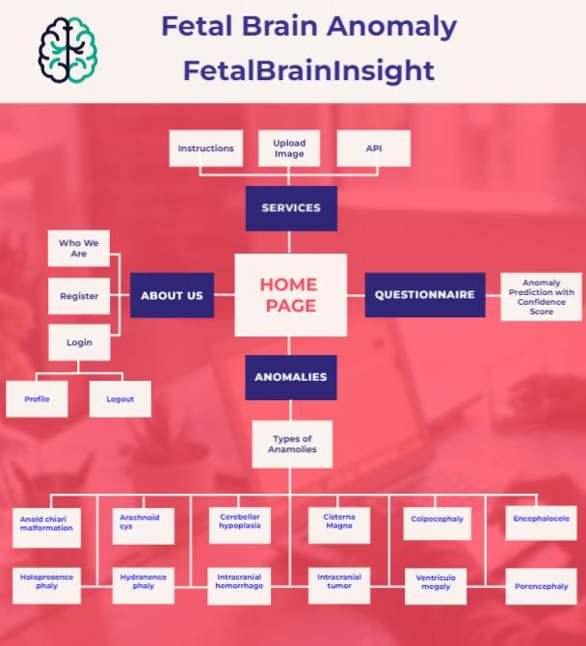

* Users can register or log in to access our services. After registering, they have their own profile and can log out when done.
* On the home page, users can explore different services like learning about anomalies, uploading images for detection, and using our system through a third-party API.
* They can also answer a questionnaire that uses NLP and AI, along with a chatbot, to predict anomalies with a confidence score, providing a second opinion.
* Additionally, our system can classify and detect anomalies in CT scan images that users upload.

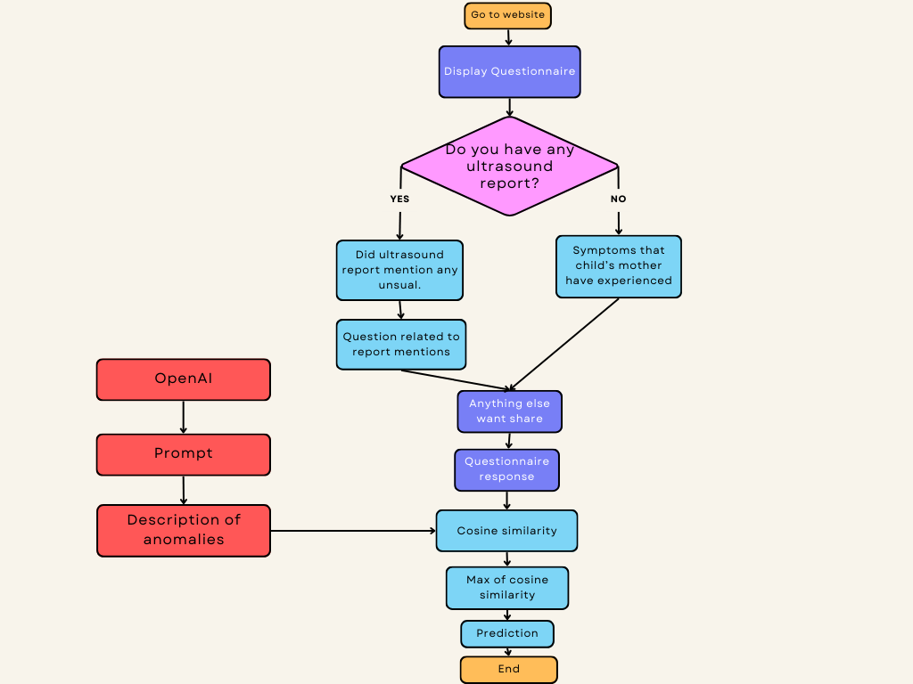

Step1: Start at "Go to website."

Step 2: "Display Questionnaire."

Step 3: Ask the user "Do you have any ultrasound report?"

Step 3.1: If "YES," then ask the question "Did the ultrasound report mention anything unusual?"

Step 3.1.1: If "YES," then ask "Question related to report mentions."

Step 3.1.2: If "NO," the flow goes "Prompt," followed by "Description of anomalies." where user select appropriate description

Step 3.2: If "NO," then moves to "Symptoms that child's mother has experienced."

Step 4: Ask the user if they have "Anything else want to share?"

Step 5: Now we have the "Questionnaire response."

Step 6: Apply "Cosine similarity." between response and symptoms of anomaly

Step 7: Calculate "Max of cosine similarity."

Step 8: The maximum cosine similarity is our "Prediction."

Step 9: "End."

**5.3 Dataset source and utilization**

Source: <https://universe.roboflow.com/computer-vision-m75wg/fetal-brain-abnormality-classification/browse?queryText=&pageSize=50&startingIndex=0&browseQuery=true>

Utilization:

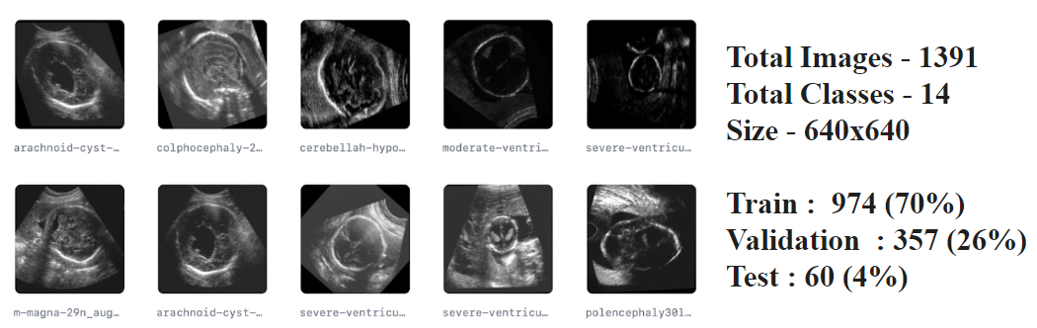

**Chapter 6: Testing of the Proposed System**

**6.1 Introduction to Testing**

Testing plays a crucial role in ensuring the effectiveness and reliability of any proposed system, especially in the domain of fetal brain anomaly detection. In this chapter, we present the testing methodology employed to evaluate the proposed system's performance, focusing on the integration of YOLOv7 and U-Net algorithms for fetal brain anomaly detection.

**6.2 Types of Tests Considered**

Several types of tests were considered to assess different aspects of the proposed system:

**6.2.1 Unit Testing:**

* Unit testing was conducted to evaluate individual components of the algorithms, such as YOLOv7's object detection capabilities and U-Net's segmentation accuracy.

**6.2.2 Integration Testing:**

* Integration testing aimed to assess the interoperability and coherence of the combined YOLOv7 and U-Net algorithms within the system architecture.

**6.2.3 Functional Testing:**

* Functional testing involves validating whether the system performs its intended functions correctly, such as detecting fetal brain anomalies accurately.

**6.2.4 Performance Testing:**

* Performance testing measured the system's efficiency, including processing speed, resource utilization, and overall accuracy in anomaly detection.

**6.3 Various Test Case Scenarios Considered**

Several test case scenarios were considered to comprehensively evaluate the proposed system's capabilities:

**6.3.1 Detection of Fetal Brain Anomalies:**

* Test scenarios were designed to simulate various fetal brain anomalies, including ventriculomegaly, agenesis of the corpus callosum, and holoprosencephaly.

**6.3.2 Different Imaging Modalities:**

* The system was tested with different imaging modalities commonly used in prenatal imaging, such as ultrasound and Ultrasound, to assess its versatility and robustness.

**6.3.3 Noise and Distortion:**

* Test cases involving noisy and distorted images were considered to evaluate the system's resilience to real-world imaging challenges.

**6.3.4 Varied Gestational Ages:**

* Tests were conducted using fetal brain images at different gestational ages to assess the system's performance across various stages of prenatal development.

**6.4 Inferences Drawn from the Test Cases**

Based on the test cases conducted, the following inferences were drawn regarding the performance of the proposed system:

**6.4.1 Robust Detection:**

* The system demonstrated robust detection capabilities across a range of fetal brain anomalies, achieving high accuracy rates in anomaly localization and classification.

**6.4.2 Versatility:**

* The system exhibited versatility in handling different imaging modalities and was effective in detecting anomalies regardless of the imaging technique used.

**6.4.3 Resilience to Noise:**

* Despite the presence of noise and distortion in some test cases, the system maintained reliable performance, indicating its resilience to image artifacts.

**6.4.4 Gestational Age Sensitivity:**

* Performance varied slightly across different gestational ages, with optimal results observed in mid to late gestational stages due to the increased visibility of brain structures.

**7. Results and Discussion**

**7.1 Screenshots of User Interface**

7.1.1 Questionnaire ModuleIf “yes” is selected

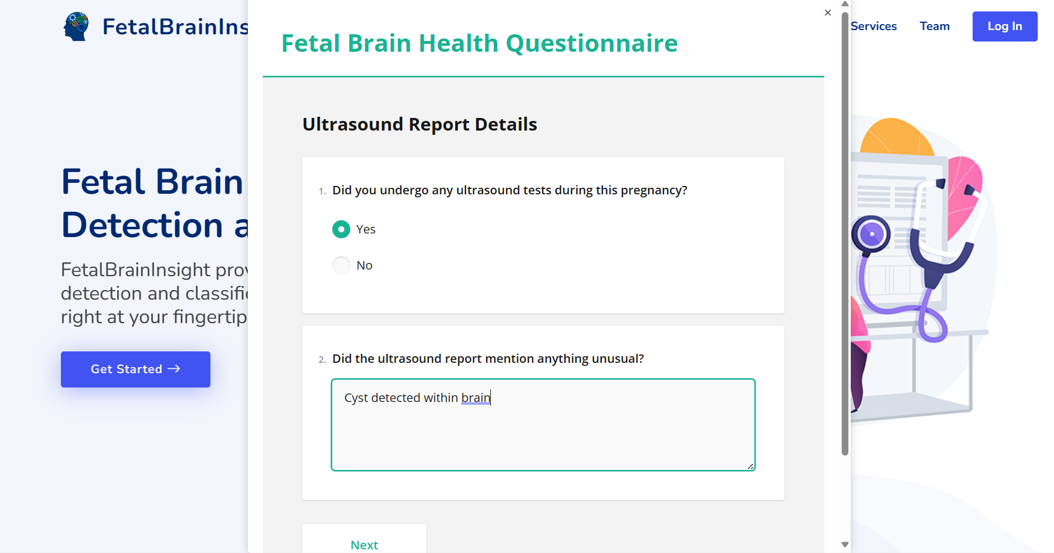

Figure 7.1.1 : Ultrasound Report (yes)

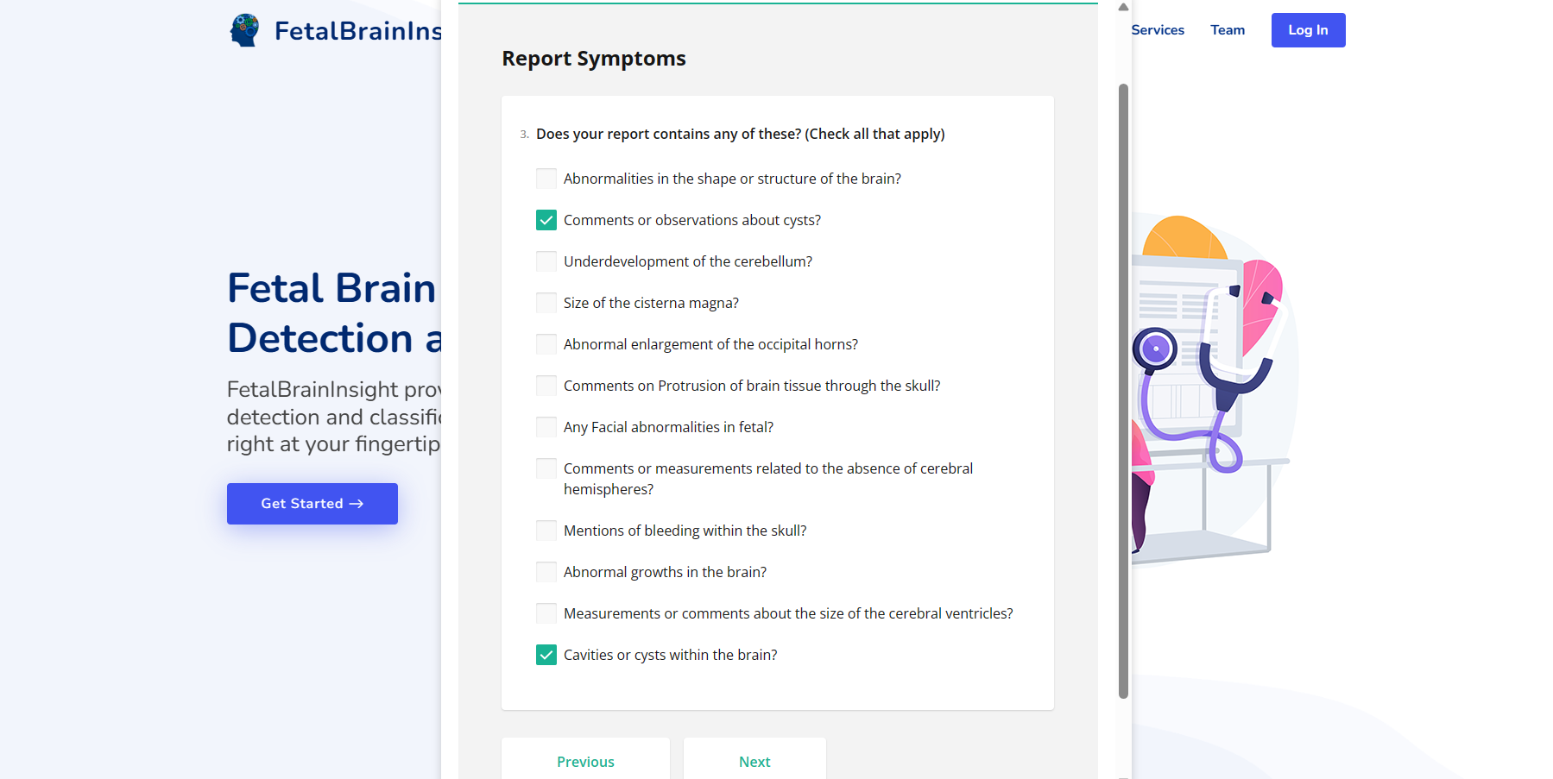

Figure 7.1.2 : Report Symptoms

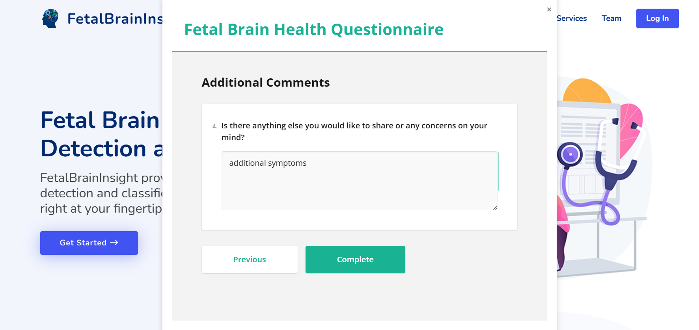

Figure 7.1.3 : Additional Comments

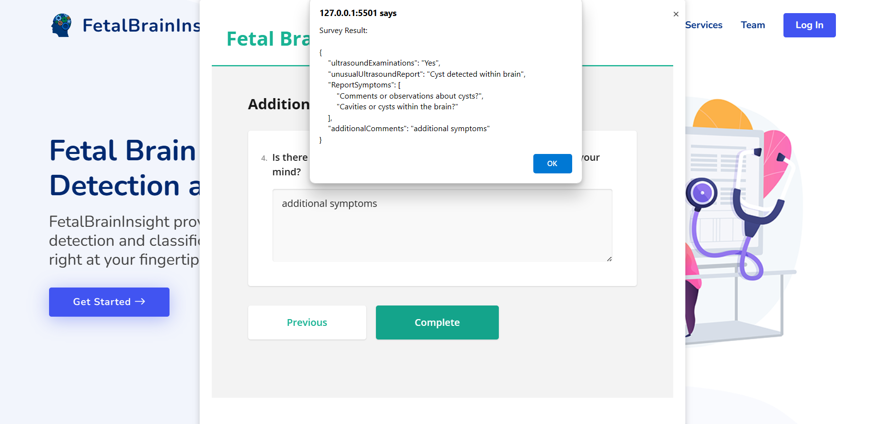

Figure 7.1.4 : Survey Result

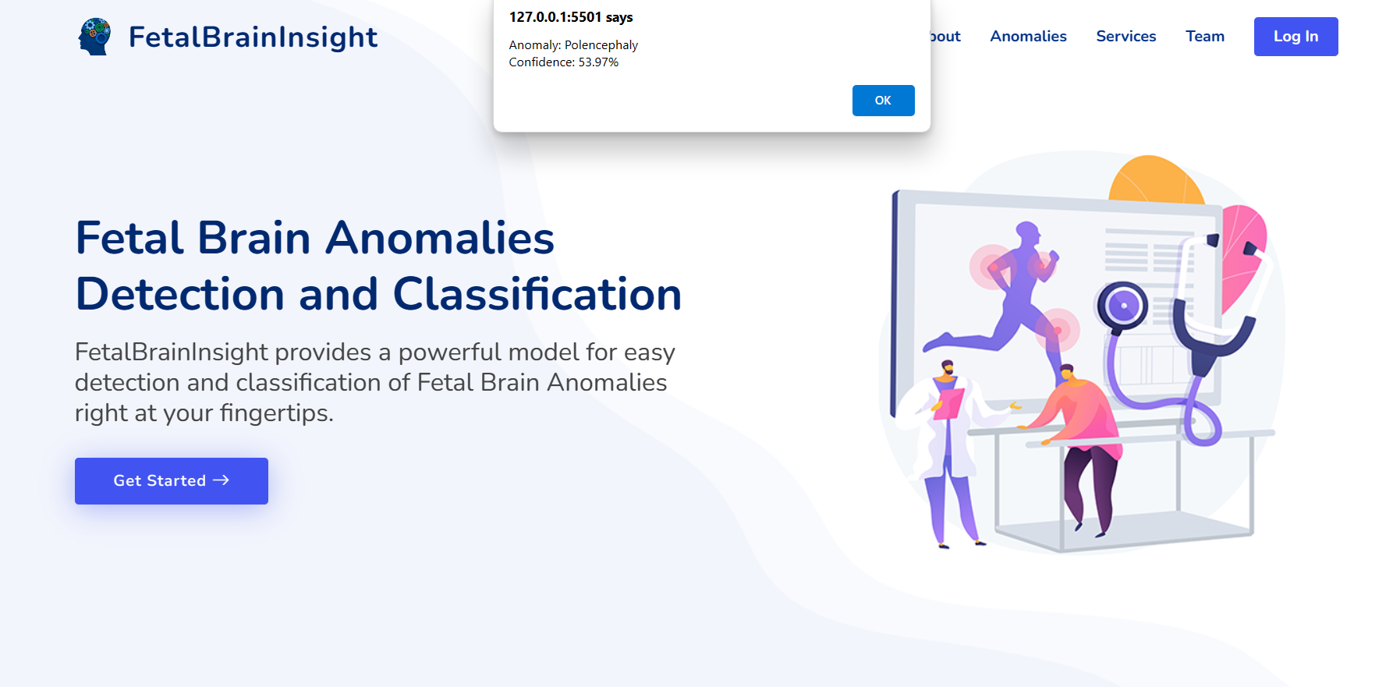

Figure 7.1.4 : Prediction

If “No” is selected

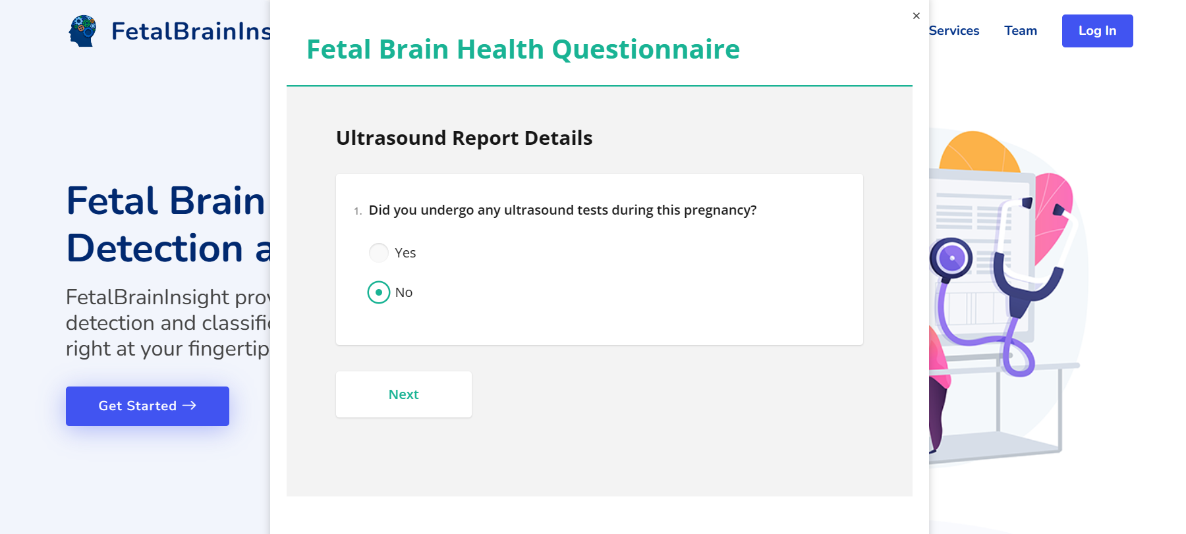

Figure 7.1.5 : Ultrasound Report (no)

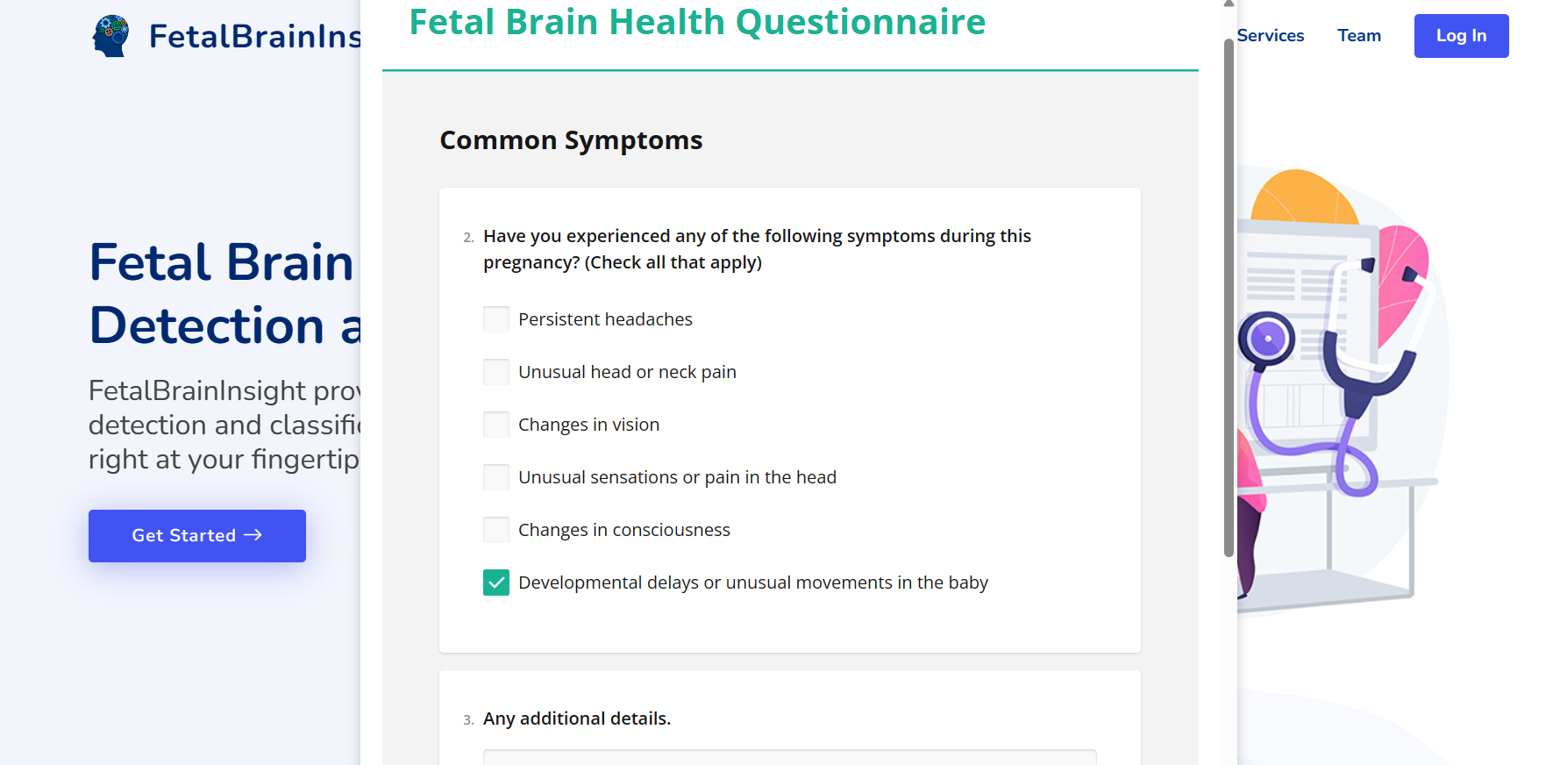

Figure 7.1.6 : Common Symptoms

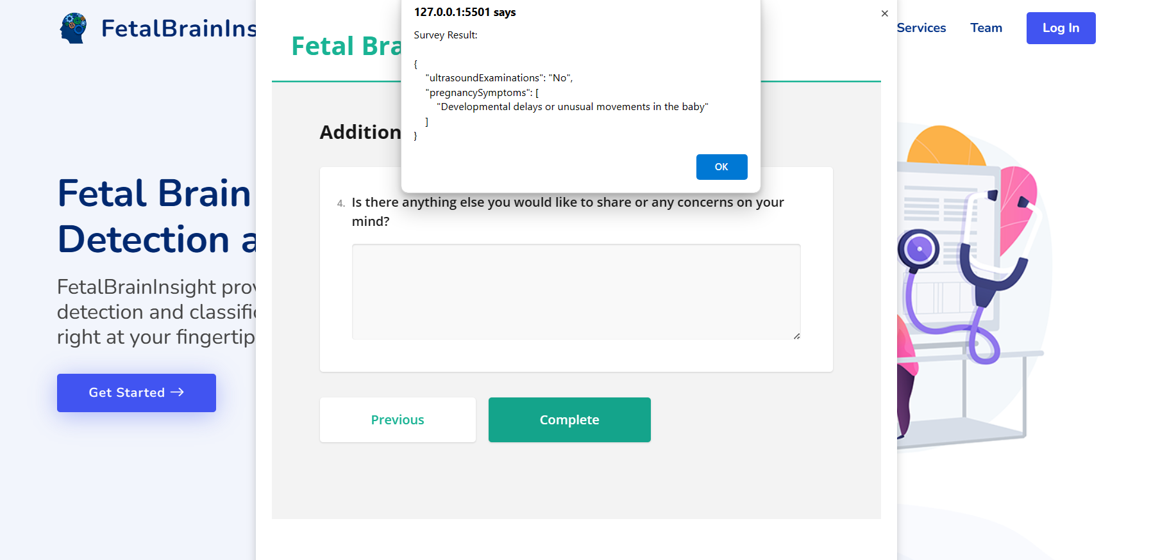

Figure 7.1.7 : Survey Result

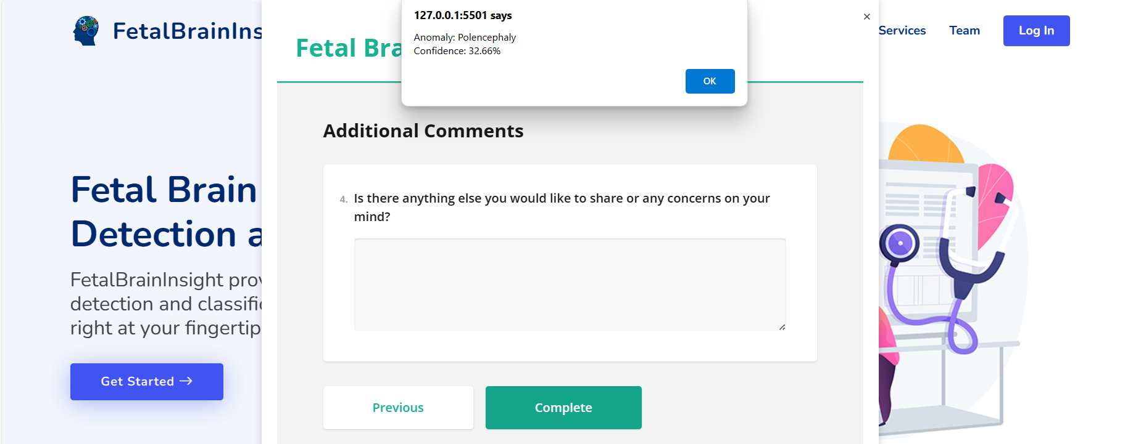

Figure 7.1.8 : Prediction

7.1.2 Registration and Login Module

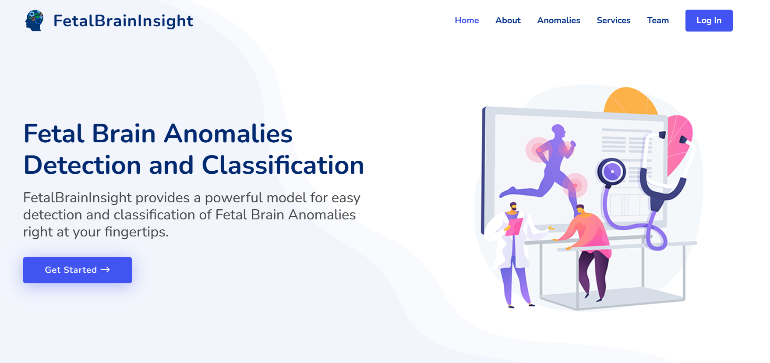

Figure 7.2.1 : Home Page 1

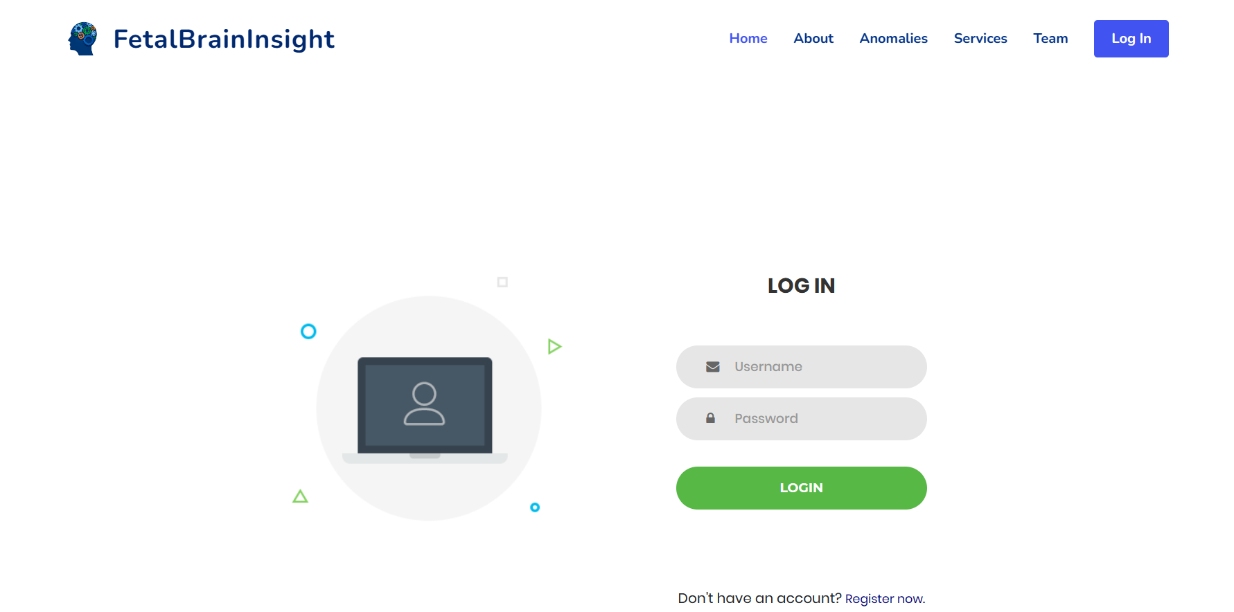

Figure 7.2.2 : Login / Registration

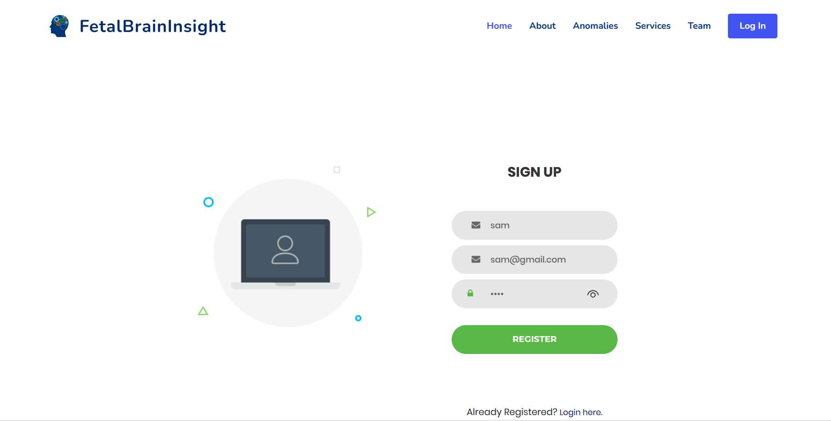

Figure 7.2.3 : Registration Credentials

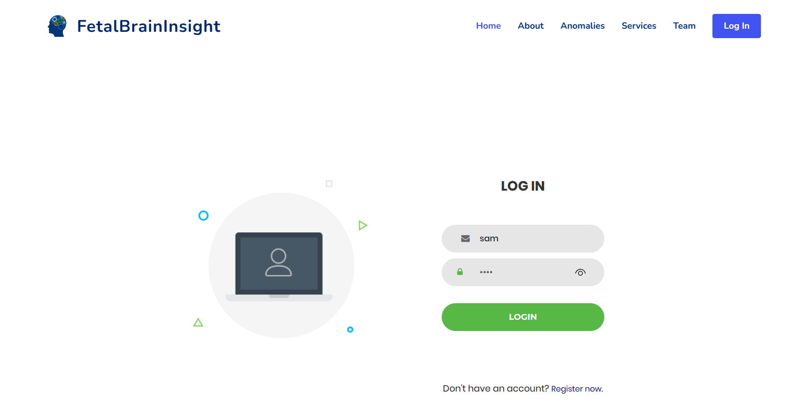

Figure 7.2.4 : Login

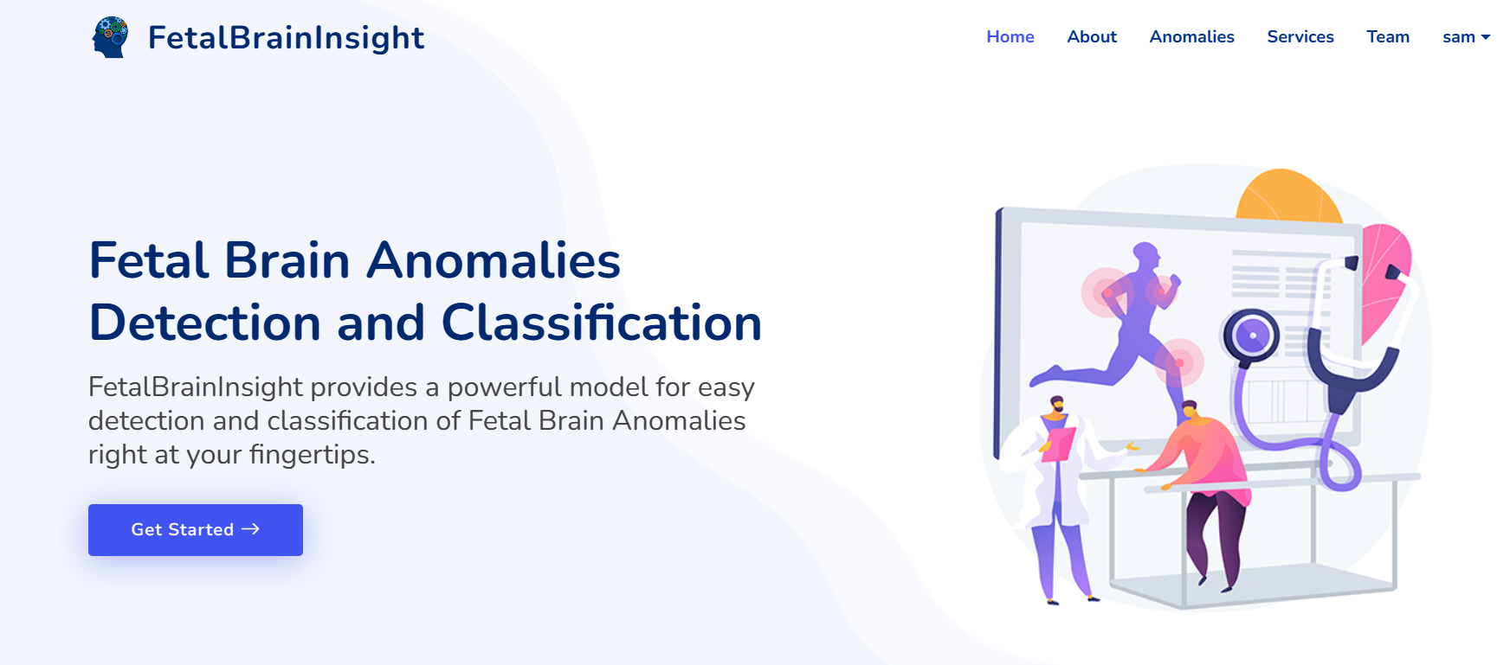

Figure 7.2.5 : Home Page 2

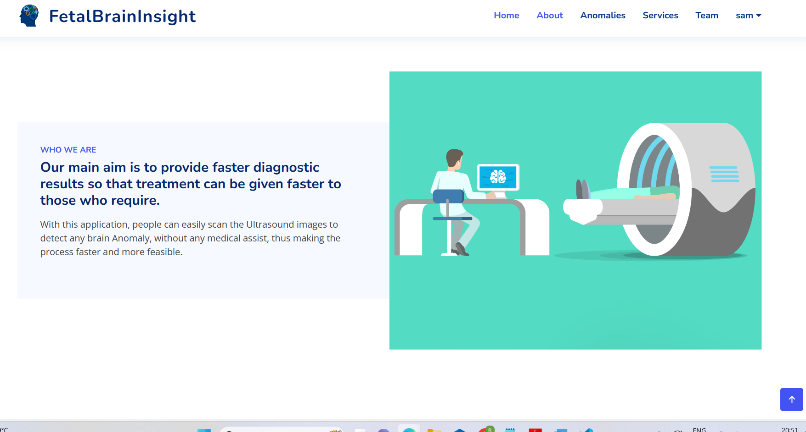

Figure 7.2.6 : About

7.1.3 Anomalies Module

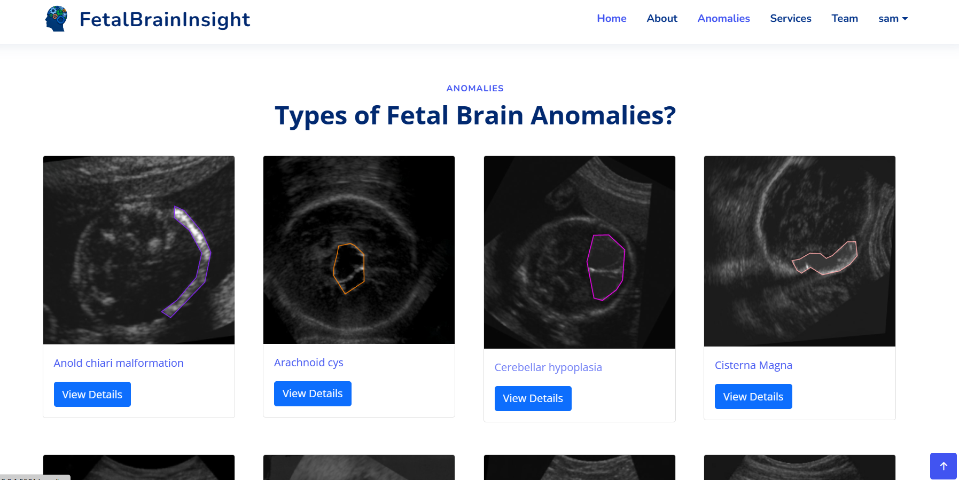

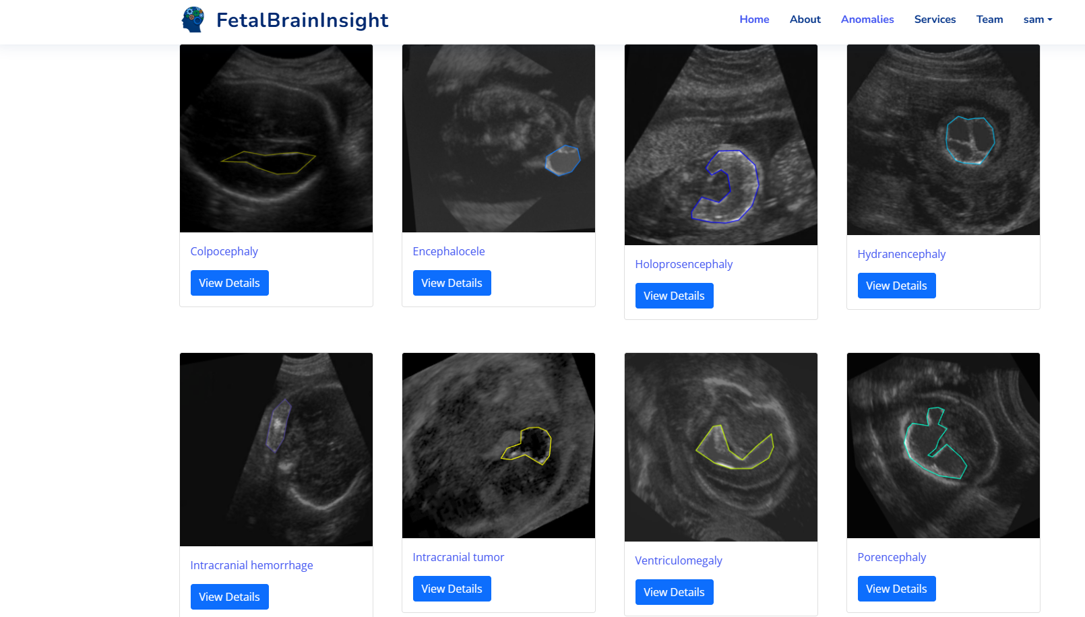

Figure 7.2.6 : Types

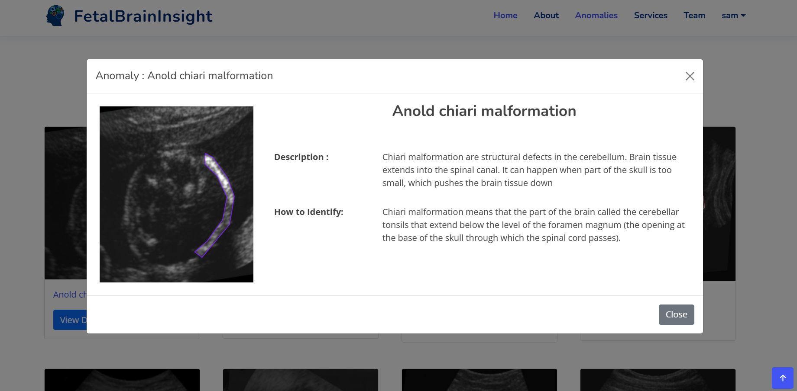

Figure 7.2.6 : Description

7.1.4 Services Module

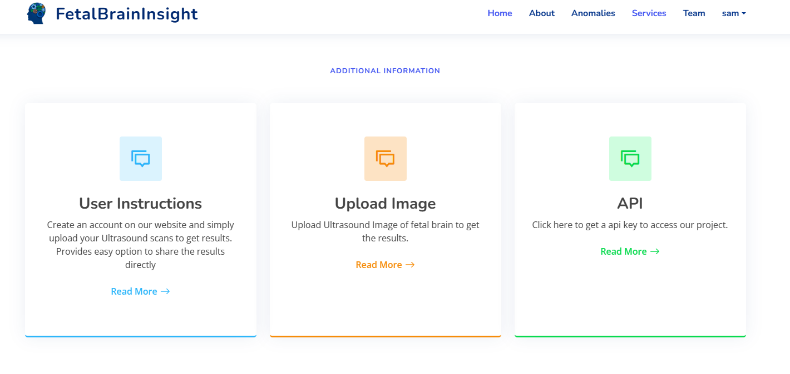

**Profile module**

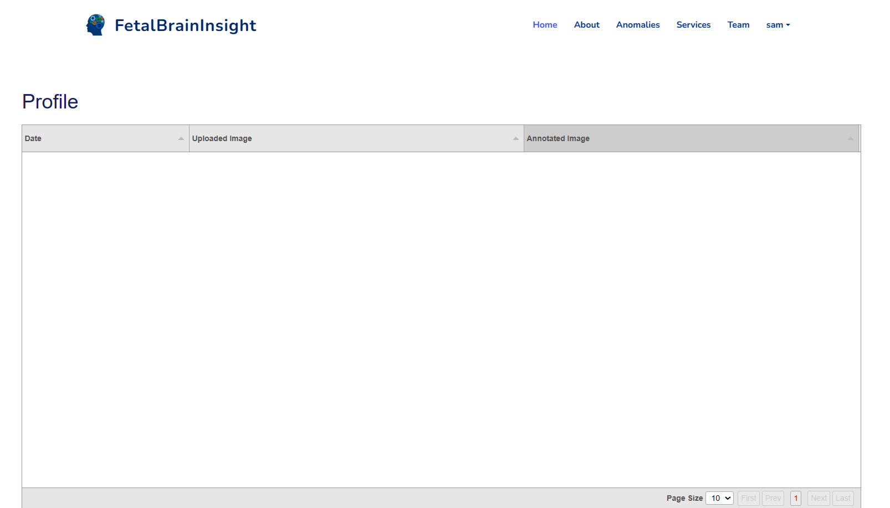

**Services module**

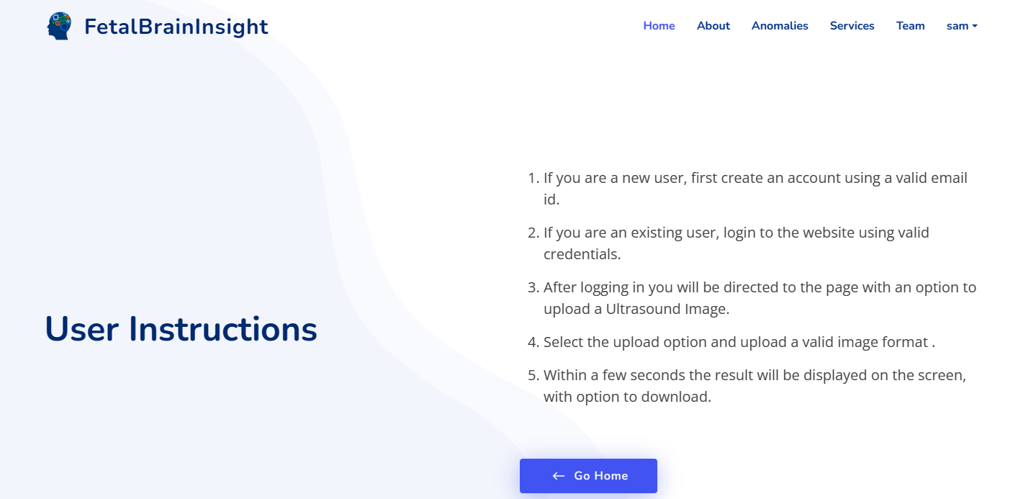

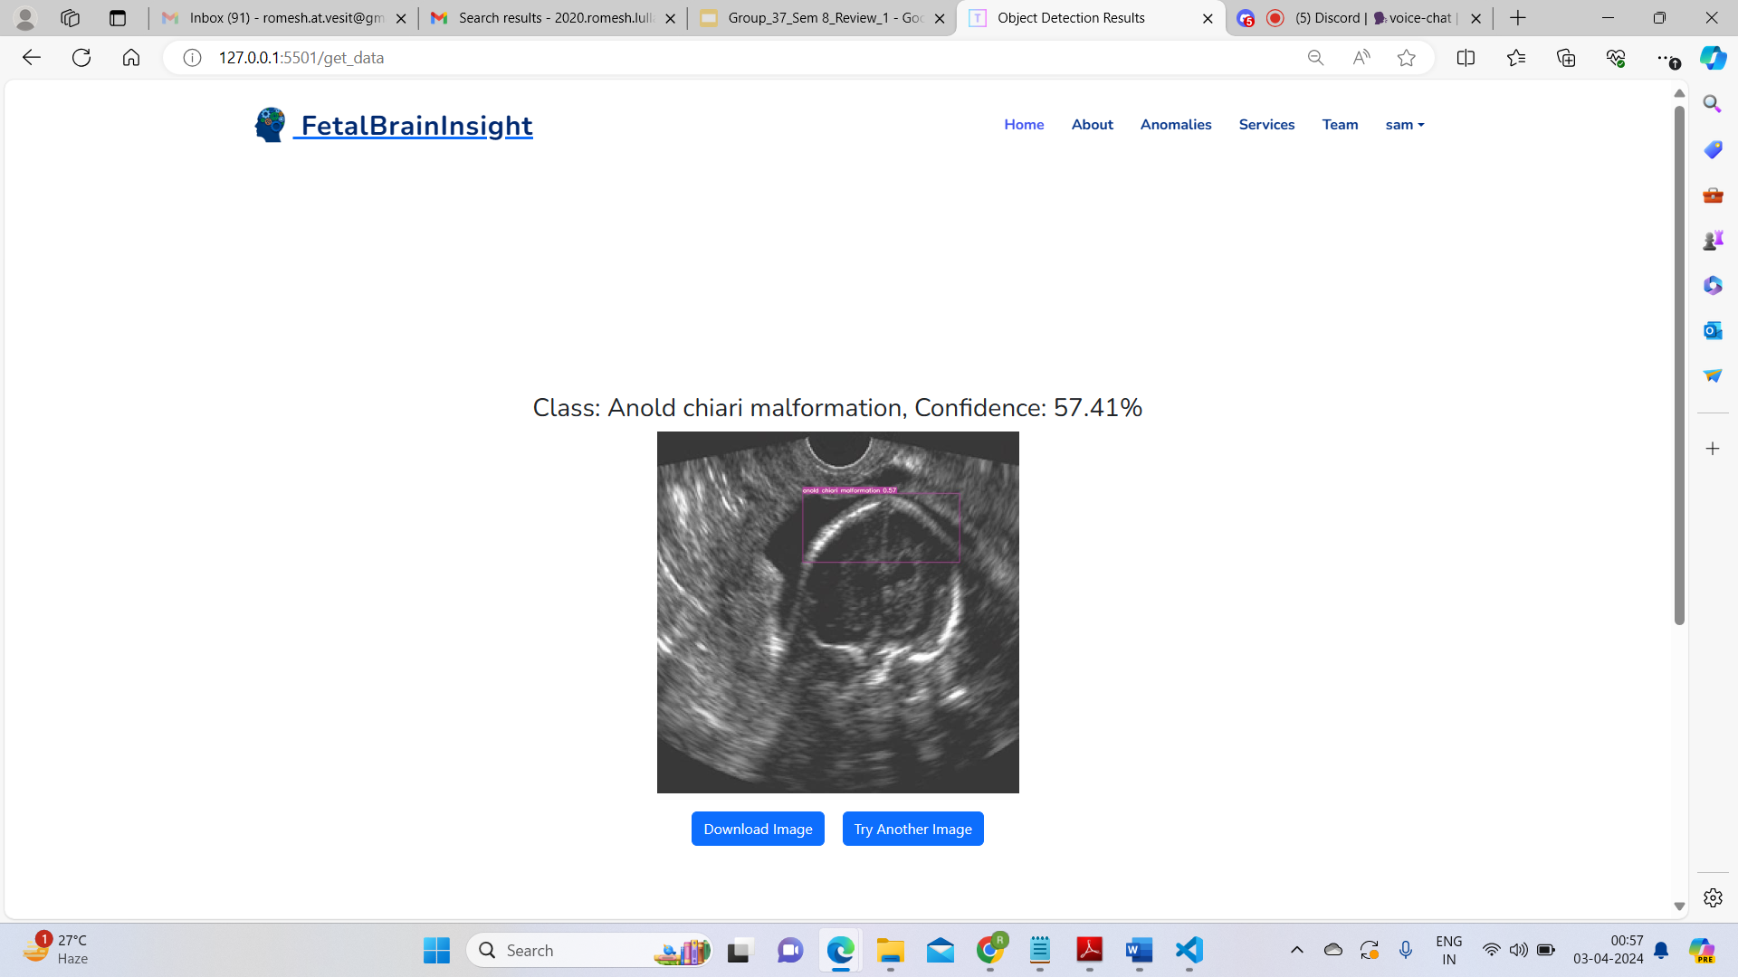

Yolo Result :

Proposed output , equations and parameters of evaluation expected for the system :-

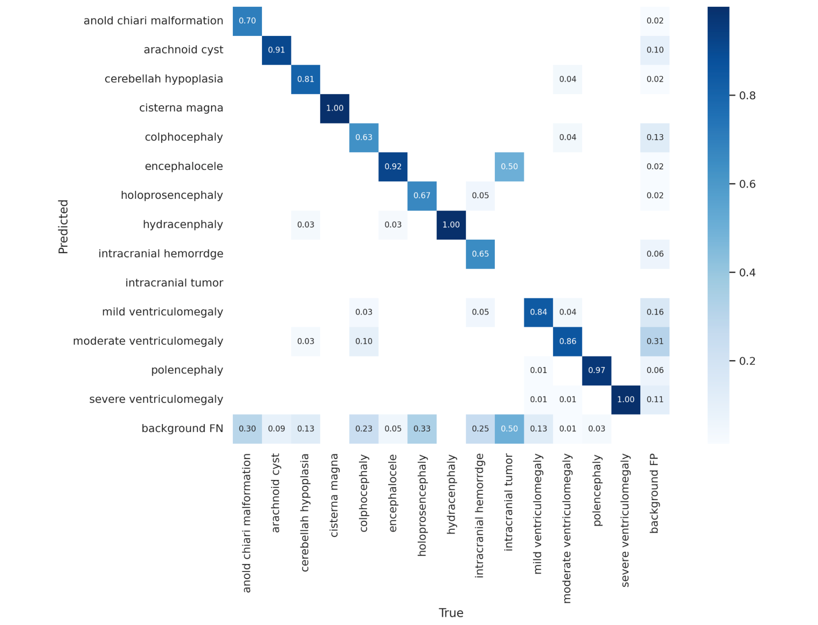

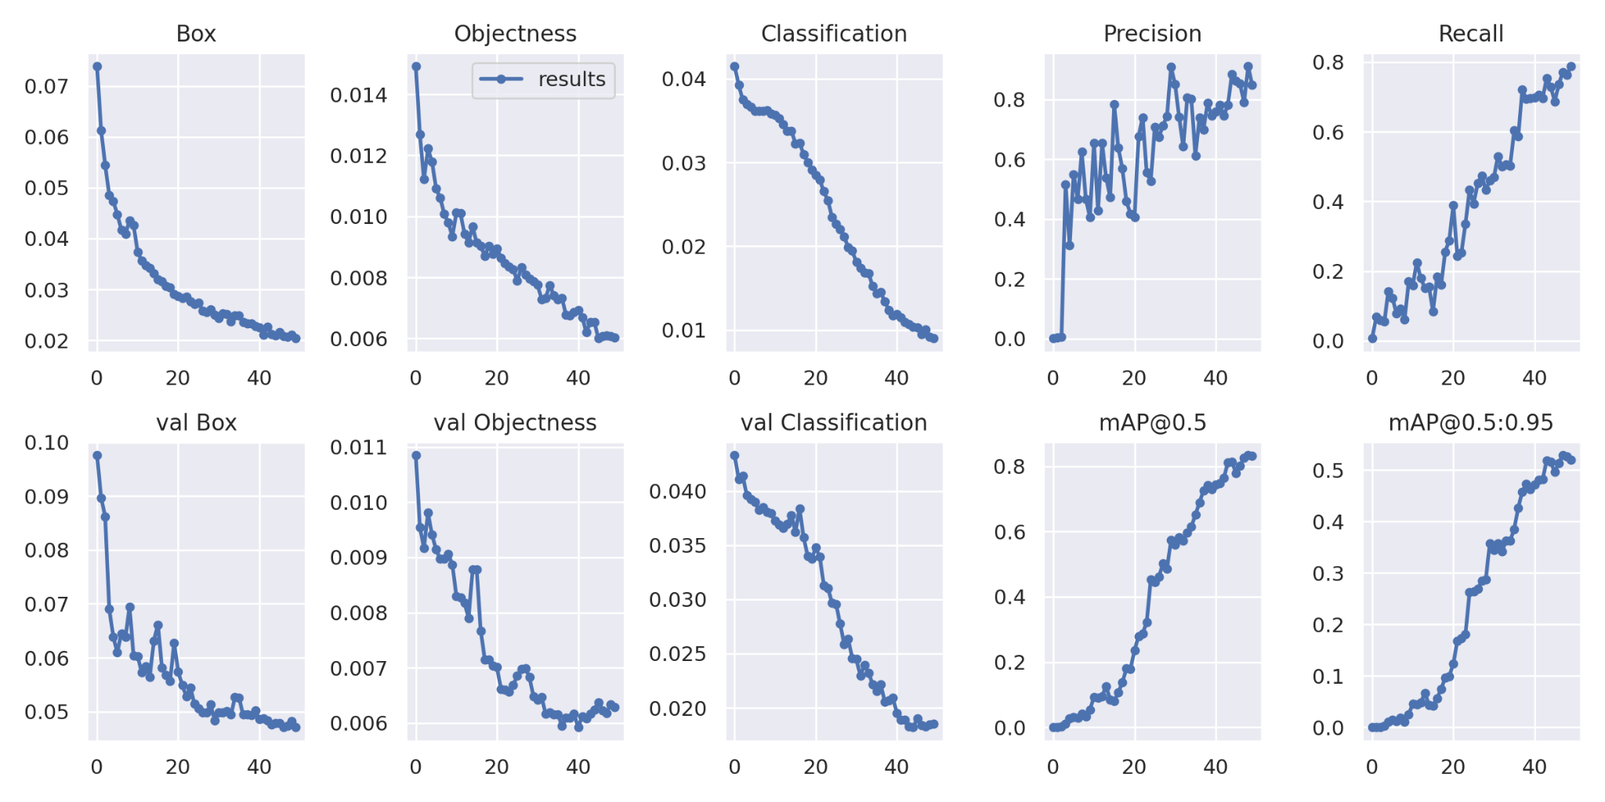

Unet Result :

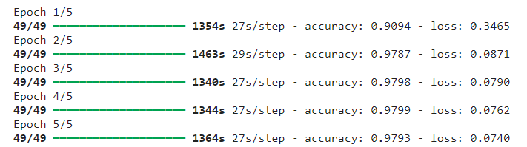

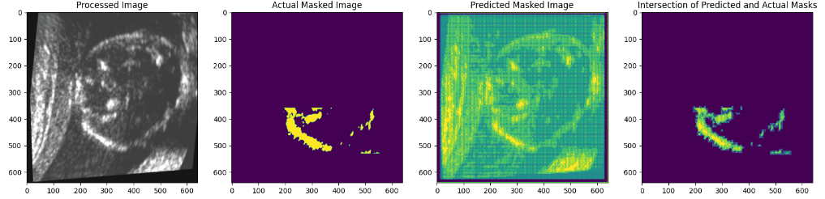

**8. Conclusion**

**8.1 Limitations**

1. Our system does not currently support multi-class segmentation tasks, limiting its ability to accurately segment images containing multiple distinct classes.

2. The categorical accuracy of our system varies significantly across different classes, indicating a need for improvement in accurately categorizing images into their respective classes.

**8.2 Conclusion**

Detecting fetal brain anomalies is a complex problem in computer-aided diagnosis (CAD) that is not easily solved. To achieve accurate classification, this model is built to analyze ultrasound images of mothers during the gestation period to determine whether the images are classified into 14 classes of various fetal brain anomalies.

An approach based on deep learning is proposed in this project that can help to detect fetal brain anomalies. The diagnosis is made based on ultrasound images, which are less distorted, lower in noise, and more precise than Ultrasound scans.

Our system utilizes OpenAI and a questionnaire, along with additional symptoms reported by the mother, to provide a secondary opinion on potential anomalies, aiding in prediction.

The project implemented two cutting-edge object detection algorithms, YOLOv5 and YOLOv7. YOLOv7 achieved 84.3% accuracy compared to YOLOv5's 80.4%, highlighting its superior detection capabilities. Additionally, UNet was utilized for semantic segmentation, achieving an impressive accuracy of 98.3%.

**8.3 Future Scope**

1. Implementing multi-class segmentation is feasible using UNet within our system.

2. UNet employs semantic segmentation techniques, and we can explore algorithms from instance segmentation for a comparative analysis.

3. Enhancements to the model will enable anomaly detection in videos, expanding its utility beyond static images.

**9. References**

[1]. H. Shankar, A. Narayan and S. Devalla, "Leveraging clinically relevant biometric constraints to supervise a deep learning model for the accurate caliper placement to obtain sonographic measurements of the fetal brain," in 2022 IEEE 19th International Symposium on Biomedical Imaging (ISBI), 2022, pp. 1234-1238.

[2]. K. Shinde and A. Thakare, "Deep Hybrid Learning Method for Classification of Fetal Brain Abnormalities," in 2021 International Conference on Artificial Intelligence and Machine Vision (AIMV), 2021, pp. 1-5.

[3]. Sharif, M.I., Khan, M.A., Alhussein, M. et al. “A decision support system for multimodal brain tumor classification using deep learning.” Complex Intell. Syst. (2021).

[4]. P. Durgadevi, S. Vijayalakshmi, and M. Sabbharwal, "Scrutiny In-Utero to recognize Fetal Brain MRI Anomalies," in 2021 3rd International Conference on Advances in Computing, Communication Control and Networking (ICACCCN), pp. 1799, 2021.

[5]. L. Liao, X. Zhang, F. Zhao, J. Lou, L. Wang, X. Xu, H. Zhang, and G. Li, "Multi-branch deformable convolutional neural network with label distribution learning for fetal brain age prediction," in 2020 IEEE 17th International Symposium on Biomedical Imaging (ISBI), April 3-7, 2020.

[6]. R. Qu, G. Xu, C. Ding, W. Jia, and M. Sun, "Standard Plane Identification in Fetal Brain Ultrasound Scans Using a Differential Convolutional Neural Network," IEEE Access, vol. 8, pp. 71009-71017, 2020.

[7]. Sunita M. Kulkarni, G. Sundari “Brain MRI Classification using Deep Learning Algorithm”, International Journal of Engineering and Advanced Technology (IJEAT) ISSN: 2249 – 8958, Volume-9 Issue-3,February, 2020.

[8]. W. Shi, G. Wang, Y. Zhang, Y. Zou, and D. Wu, "Fetal brain age estimation and anomaly detection using attention-based deep ensembles with uncertainty," NeuroImage, vol. 223, p. 117316, 2020.

[9]. B. Xie, T. Lei, N. Wang, H. Cai, J. Xian, M. He, L. Zhang, and H. Xie, "Computer-aided diagnosis for fetal brain ultrasound images using deep convolutional neural networks," Int. J. Comput. Assisted Radiol. Surg., vol. 15, no. 7, pp. 1151-1159, 2020.

[10]. H. N. Xie, N. Wang, M. He, J. Zheng, and Y. Z. Yang, "Using deep-learning algorithms to classify fetal brain ultrasound images as normal or abnormal," Ultrasound Obstet Gynecol, vol. 56, pp. 579-587, 2020.

[11]. G. Xu, C. Ding, W. Jia, and M. Sun, "Deep Learning-Based Methodology for Recognition of Fetal Brain Standard Scan Planes in 2D Ultrasound Images," IEEE Access, vol. 7, pp. 150120-150129, 2019.

[12]. I. B. Van den Veyver, "Prenatally diagnosed developmental abnormalities of the central nervous system and genetic syndromes: A practical review," IEEE, 2019.

**6. Plan of action for the next semester**

**a. Work done till date**

**1. Study of Existing System:** The project started with an in-depth study of the existing systems and technologies used for medical image analysis, focusing on brain anomaly detection.

**2. Annotated Data Collection:** Substantial efforts were dedicated to collecting and annotating a diverse dataset of medical images, including brain scans. This annotated data forms the basis for model training.

**3. Preprocessing:** The collected data underwent preprocessing, which involved various techniques to enhance image quality and prepare it for analysis. This step is crucial for accurate anomaly detection.

**4. Identification of Various Anomalies:** The team identified and categorized various brain anomalies that the YOLO models would aim to detect, including tumors, lesions, and structural irregularities.

**b. Plan of action for project II**

The development process involves several key components:

**1.** **Third-Party API Integration:** Incorporate third-party APIs to enhance the functionality of the system. These APIs can provide additional data sources or services that complement the core application.

**2. User Model Upload:** Allow users to upload their pre-trained machine learning models, granting them the flexibility to utilize their own algorithms and expertise within the platform.

**3. U-Net Implementation:** Integrate the U-Net architecture, a deep learning model specifically designed for image segmentation tasks. This enables the system to effectively process and analyze medical images for early detection of brain anomalies.

**4. Web Application Development:** Create a web-based application utilizing frontend web frameworks and the Django web framework. This combination provides a user-friendly interface for interacting with the system's features and functionalities.

Incorporating these elements into the application will result in a powerful and flexible platform for early detection of brain anomalies through AI-enhanced imaging. Users can leverage their pre-trained models alongside the U-Net architecture, with the entire system accessible via a user-friendly web interface developed using Django and frontend web frameworks.

In light of the growing concern surrounding the increasing prevalence of fetal brain anomalies and their profound impact on a child's health and well-being, early detection and intervention have become paramount. This project has delved into the heart of this challenge, recognizing the critical role that timely diagnosis plays in improving the prognosis and outcomes for affected infants, while simultaneously supporting healthcare providers and expectant parents in their journey.

One standout development in this domain is Computer-Aided Diagnosis (CAD), which empowers doctors with an additional tool for precise and timely identification of developmental issues in the fetal brain. CAD not only promises increased accuracy but also offers the potential to address the limitations of existing approaches. This project's investigation and evaluation have aimed to harness this potential and propose an innovative model that not only enhances the diagnostic process but strives to usher in a new era of prenatal healthcare, where the early detection of fetal brain anomalies becomes not just a goal, but a readily attainable reality.

The project successfully implemented two cutting-edge object detection algorithms, YOLOv5 and YOLOv7, which represent state-of-the-art solutions in computer vision and deep learning.The comparison between YOLOv7 and YOLOv5, with YOLOv7 achieving an accuracy of 84.3% and YOLOv5 reaching 80.4%, underscores the significance of accuracy in object detection. YOLOv7 has demonstrated its prowess in delivering superior detection capabilities, making it a compelling choice in scenarios where precision is of utmost importance.

**8. References**

**Vahedifard, Farzan, Jubril O. Adepoju, Mark Supanich, Hua Asher Ai, Xuchu Liu, Mehmet Kocak, Kranthi K. Marathu, and Sharon E. Byrd. "Review of deep learning and artificial intelligence models in fetal brain magnetic resonance imaging." *World journal of clinical cases* 11, no. 16 (2023): 3725.**

[1]. H. Shankar, A. Narayan and S. Devalla, "Leveraging clinically relevant biometric constraints to supervise a deep learning model for the accurate caliper placement to obtain sonographic measurements of the fetal brain," in 2022 IEEE 19th International Symposium on Biomedical Imaging (ISBI), 2022, pp. 1234-1238.

[2]. K. Shinde and A. Thakare, "Deep Hybrid Learning Method for Classification of Fetal Brain Abnormalities," in 2021 International Conference on Artificial Intelligence and Machine Vision (AIMV), 2021, pp. 1-5.

[3]. Sharif, M.I., Khan, M.A., Alhussein, M. et al. “A decision support system for multimodal brain tumor classification using deep learning.” Complex Intell. Syst. (2021).

[4]. P. Durgadevi, S. Vijayalakshmi, and M. Sabbharwal, "Scrutiny In-Utero to recognize Fetal Brain MRI Anomalies," in 2021 3rd International Conference on Advances in Computing, Communication Control and Networking (ICACCCN), pp. 1799, 2021.

[5]. L. Liao, X. Zhang, F. Zhao, J. Lou, L. Wang, X. Xu, H. Zhang, and G. Li, "Multi-branch deformable convolutional neural network with label distribution learning for fetal brain age prediction," in 2020 IEEE 17th International Symposium on Biomedical Imaging (ISBI), April 3-7, 2020.

[6]. R. Qu, G. Xu, C. Ding, W. Jia, and M. Sun, "Standard Plane Identification in Fetal Brain Ultrasound Scans Using a Differential Convolutional Neural Network," IEEE Access, vol. 8, pp. 71009-71017, 2020.

[7]. Sunita M. Kulkarni, G. Sundari “Brain MRI Classification using Deep Learning Algorithm”, International Journal of Engineering and Advanced Technology (IJEAT) ISSN: 2249 – 8958, Volume-9 Issue-3,February, 2020.

[8]. W. Shi, G. Wang, Y. Zhang, Y. Zou, and D. Wu, "Fetal brain age estimation and anomaly detection using attention-based deep ensembles with uncertainty," NeuroImage, vol. 223, p. 117316, 2020.

[9]. B. Xie, T. Lei, N. Wang, H. Cai, J. Xian, M. He, L. Zhang, and H. Xie, "Computer-aided diagnosis for fetal brain ultrasound images using deep convolutional neural networks," Int. J. Comput. Assisted Radiol. Surg., vol. 15, no. 7, pp. 1151-1159, 2020.

[10]. H. N. Xie, N. Wang, M. He, J. Zheng, and Y. Z. Yang, "Using deep-learning algorithms to classify fetal brain ultrasound images as normal or abnormal," Ultrasound Obstet Gynecol, vol. 56, pp. 579-587, 2020.

[11]. G. Xu, C. Ding, W. Jia, and M. Sun, "Deep Learning-Based Methodology for Recognition of Fetal Brain Standard Scan Planes in 2D Ultrasound Images," IEEE Access, vol. 7, pp. 150120-150129, 2019.

[12]. I. B. Van den Veyver, "Prenatally diagnosed developmental abnormalities of the central nervous system and genetic syndromes: A practical review," IEEE, 2019.

**9.** **Appendix**

**a. List of Figures**

| Figure Number | Heading | Page no. |
| --- | --- | --- |
| 1 | Block Diagram | 25 |
| 2 | Modular Diagram | 27 |
| 3 | DFD Level 0 | 29 |
| 4 | DFD Level 1 | 30 |
| 5 | Screenshot Of Output | 31-32 |
| 6 | Evaluation Measure | 33 |
| 7 | Confusion Matrix | 34 |

**b. List of tables**

| Table Number | Heading | Page no. |
| --- | --- | --- |
| 1 | Literature Review | 14 |
| 2 | Identification of anomalies | 20 |